Overview

Direct Competitors
- https://www.g2.com/
- https://www.softwareadvice.com/
- https://www.capterra.com/
- https://softwarefinder.com/

Branding colors
https://kavi-template.framer.website/ (EXACTLY these, but on a dark background)
background:
linear-gradient(264.81deg,
#FE4A97 -18.17%,
#FA7A77 48.63%,
#A554EF 115.42%);

Themes
https://aidefault.liquid-themes.com/

Functionality Needed
- Stripe integration
- Mailchimp integration
- Strong LMS
- Advanced analytics
- Listicles and listing detail page
- Comparison pages similar to G2
- Vendor portal and review submission portal

A decent listing page https://main.mylistingtheme.com/listing/liman-restaurant/#reviews
https://docs.mylistingtheme.com/category/listing-types/ (Can we create our listing with this?)

Homepage sections

Hero Section
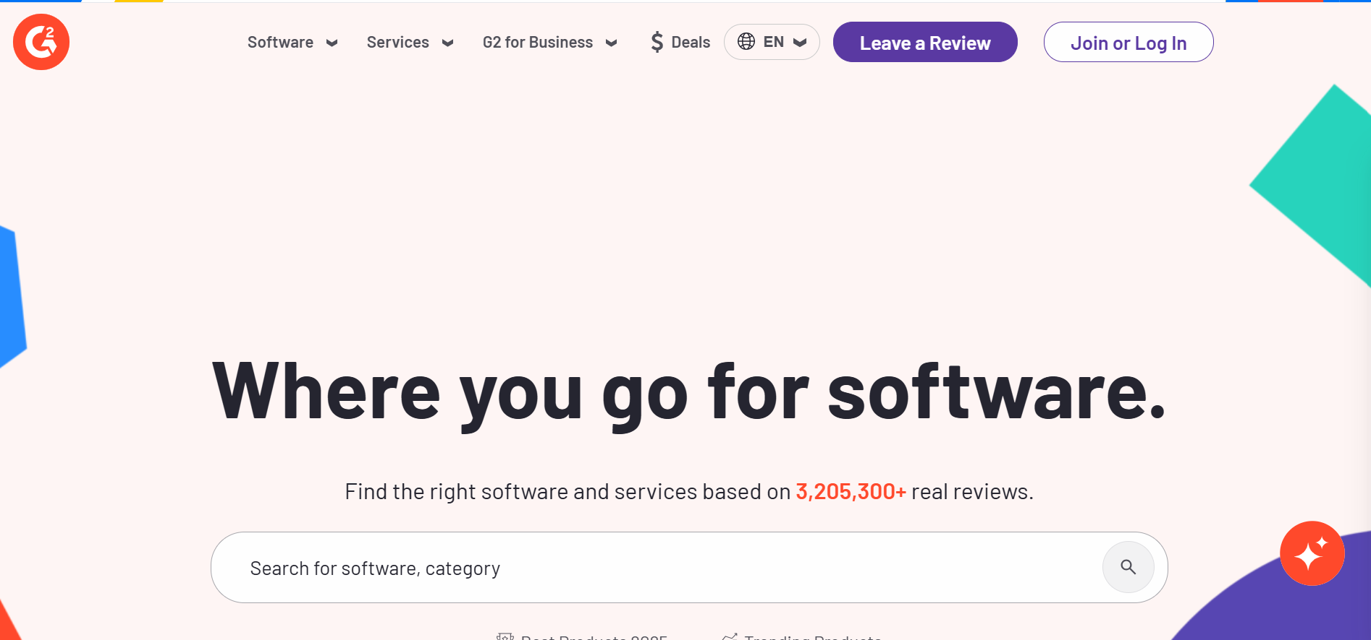
- Our homepage’s hero section would be inspired by G2’s hero section. We need a search bar similar to G2 (Will write the content later). Our hero section should have space for our tagline and h2. I don’t think we would need much changes here.
- Our nav bar would be similar to g2 as well. It would have software, industries, vendors, write a review, blog, and about us. The dropdowns are also gonna be similar to G2. We will keep the running banner on the top as well (content will be decided later).
- Similar to the links under the g2 search bar, we will also attach a couple of links in place of ‘Discover AI Hub’. (Check G2 website for reference).

Value Prop
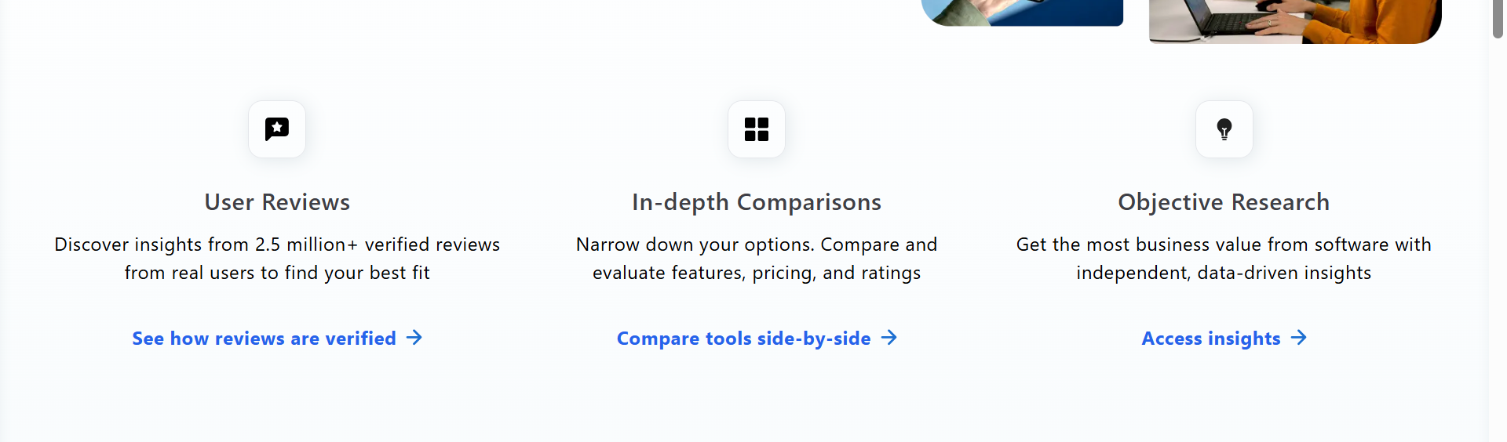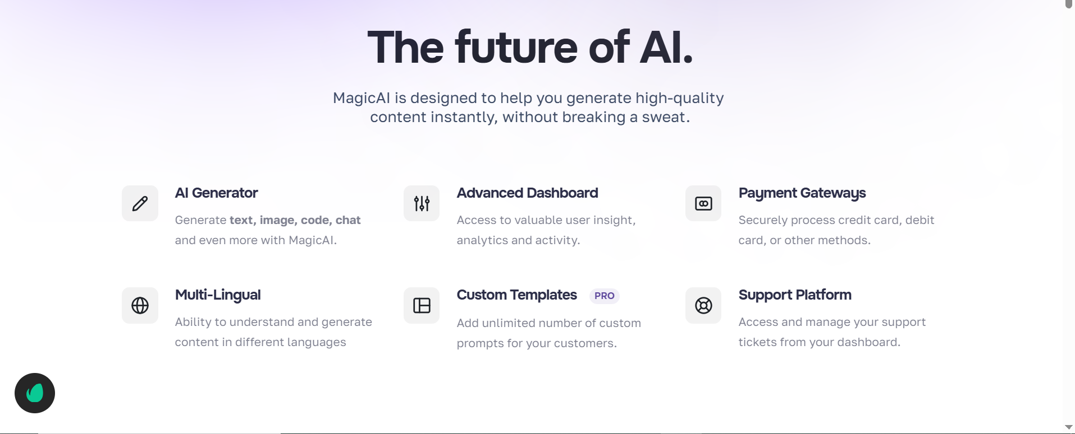
- The first one is taken from Capterra and the second one is ours. Please visit Capterra website for reference. This is the second section and it would have value propositions for Techanalytica and would define exactly what we do. This would primarily remain the same (We might change the icons based on the content).
- Nor sure if we should keep it directly under the Hero section or not. Can we take it a bit lower? Thoughts? diatariq622@gmail.com

Categories Section
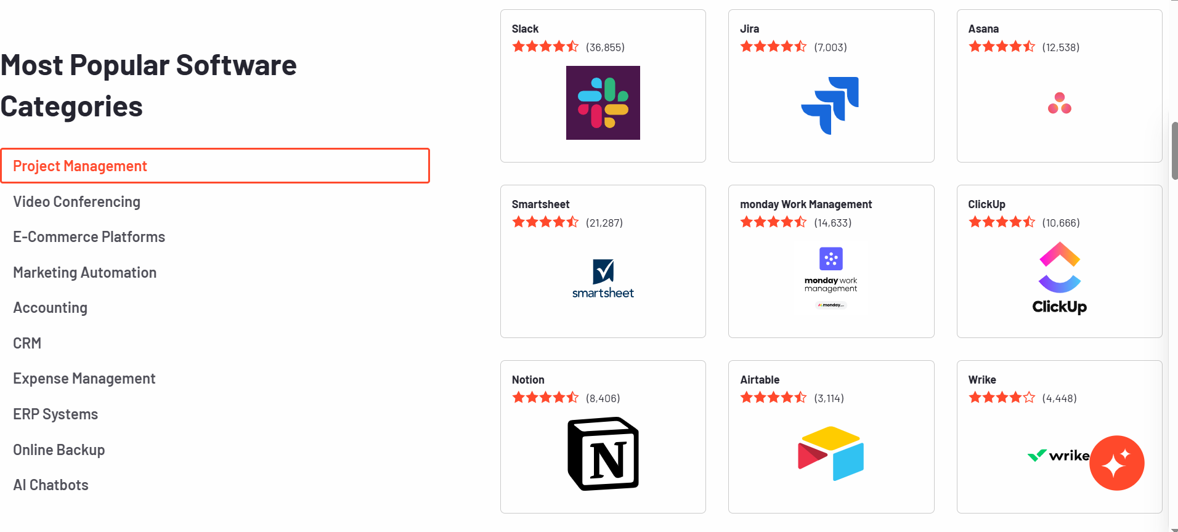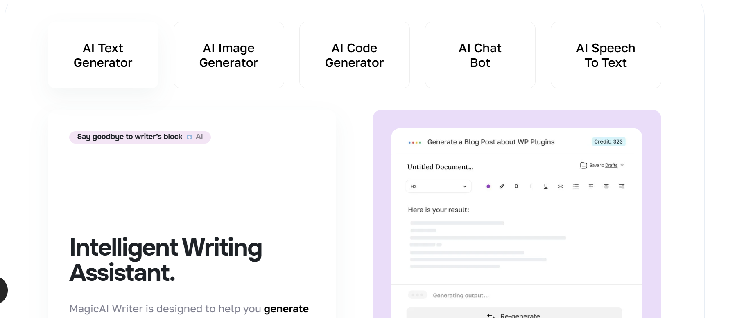
- This section would be the equivalent of the G2 Categories section. We will jot down the popular categories in place of AI Text Generation etc. Can we please make them a bit elongated? These boxes look horrendous. We can then play around with images and content. We will add a READ MORE to every category mentioned so it can be redirected to its own landing page.
- We also need to add a button here somewhere that says ‘Browse all AI categories’.

Extra Section
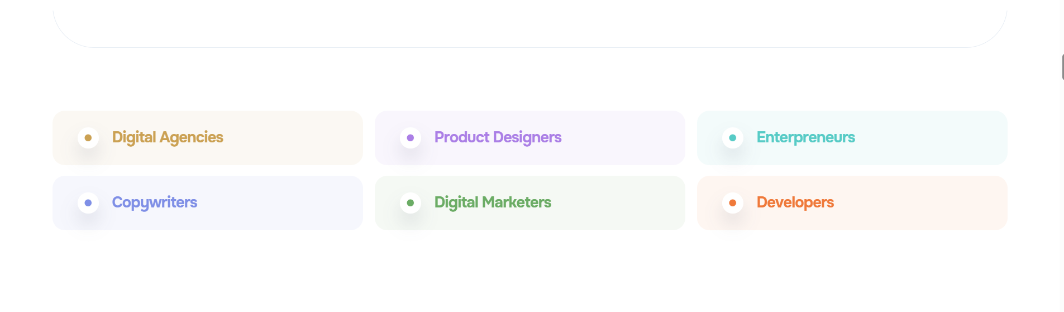
- We would like to keep this section hidden for now. Please don’t delete it, we might find a use for it later.

Vendor Section
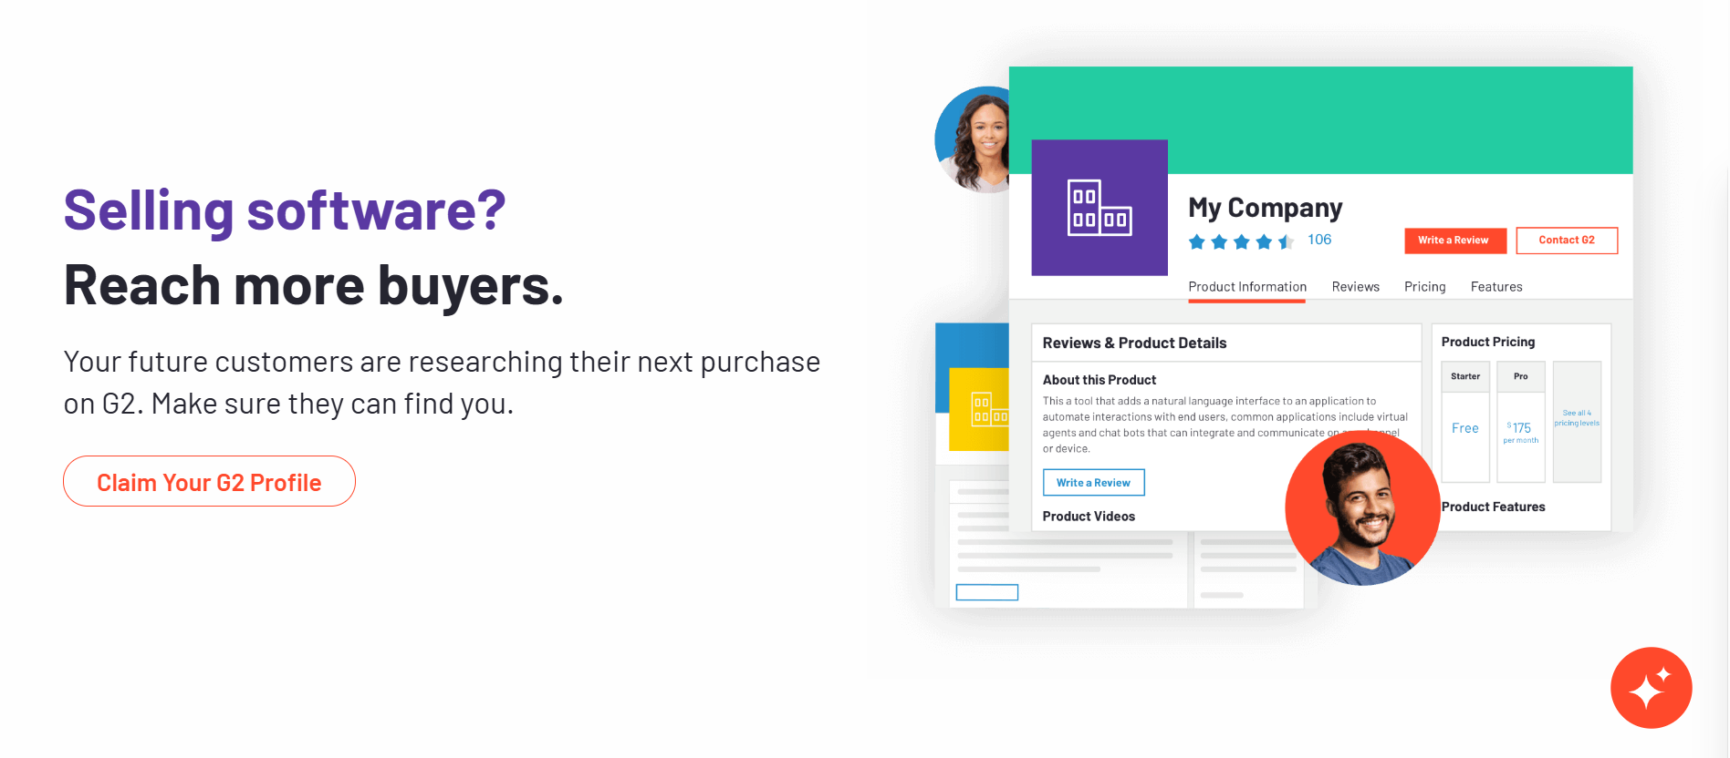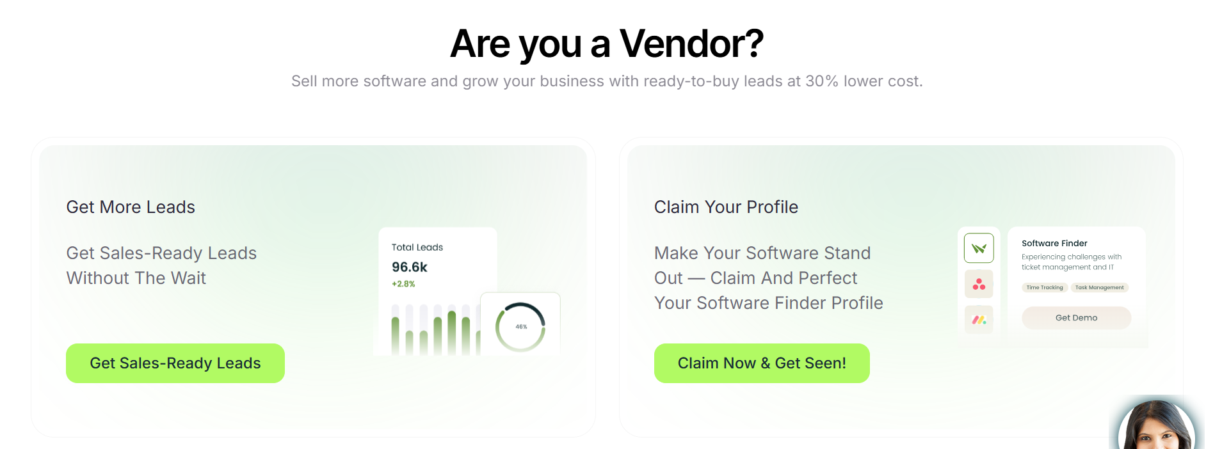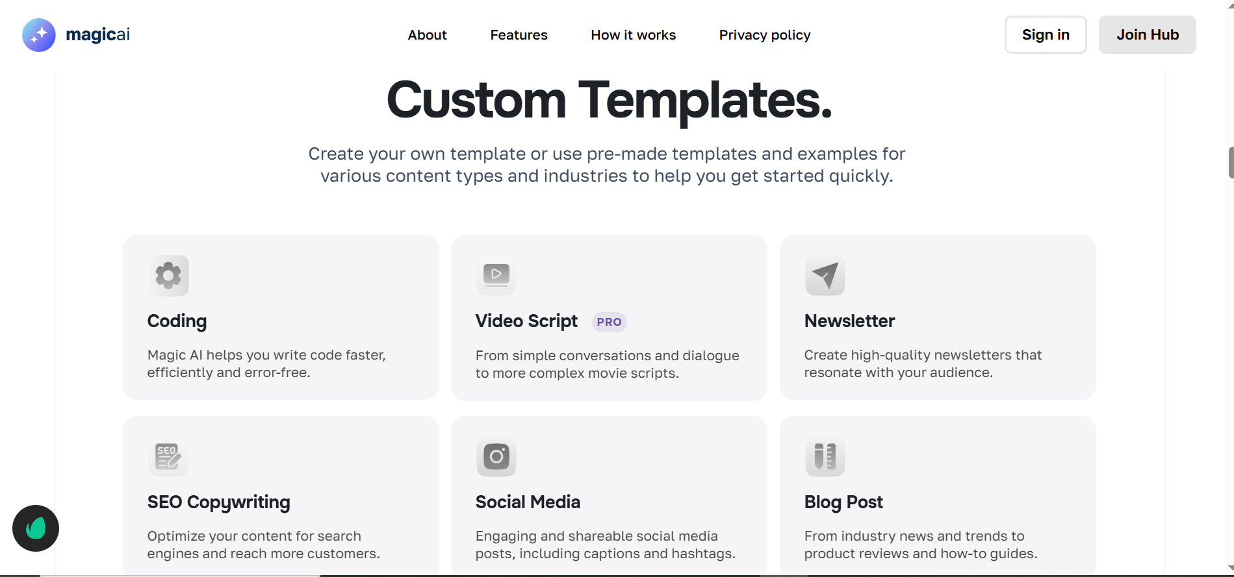
- On the top are the vendor sections at G2 and SoftwareFinder respectively. Please check their websites for reference. We want to change this Custom Template section to a Vendor section. We have not yet decided on the visuals or content for this section. diatariq622@gmail.comLet’s discuss.

Featured Software
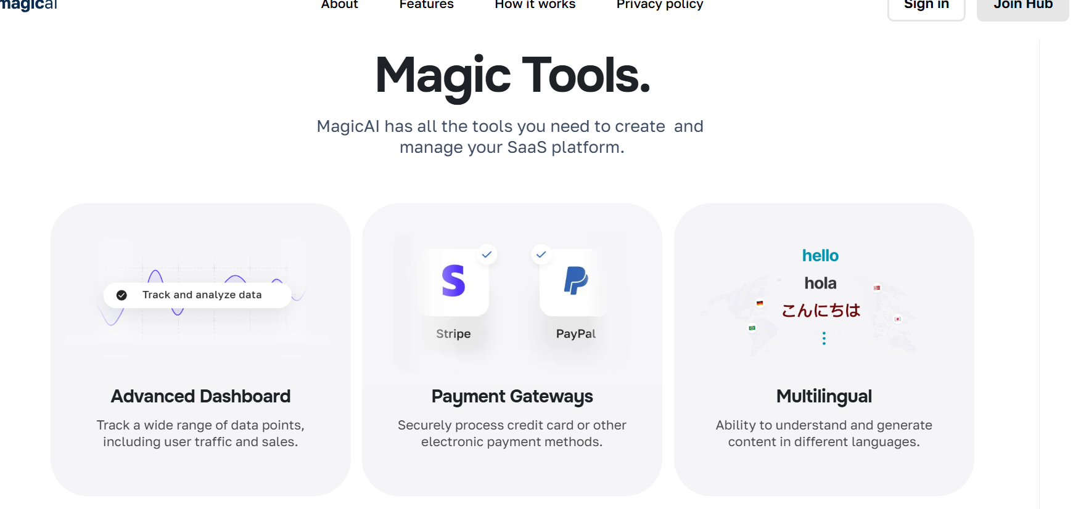
- This entire section would be the software that is sponsored by vendors for more visibility. (We should take this section to the top, right under our hero section and bring down the value prop section. Thoughts? diatariq622@gmail.com).

New Software Releases/Additions
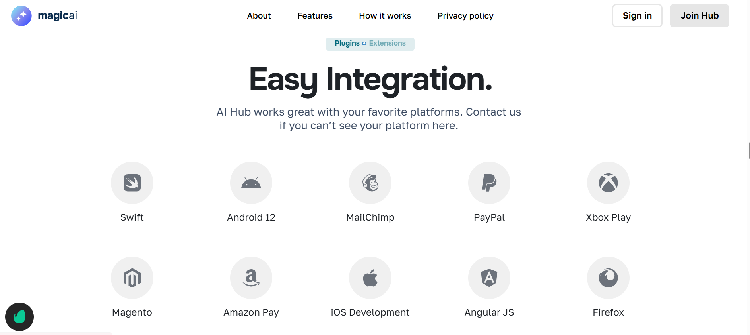
- We can use this section to list the AI tools that are JUST being launched or are just being added to our repository. Thoughts? diatariq622@gmail.com. (top 10 software per year or per quarter).

Review CTA Section
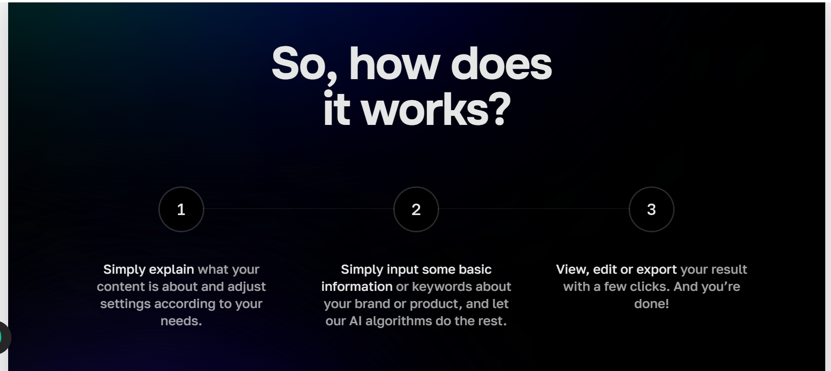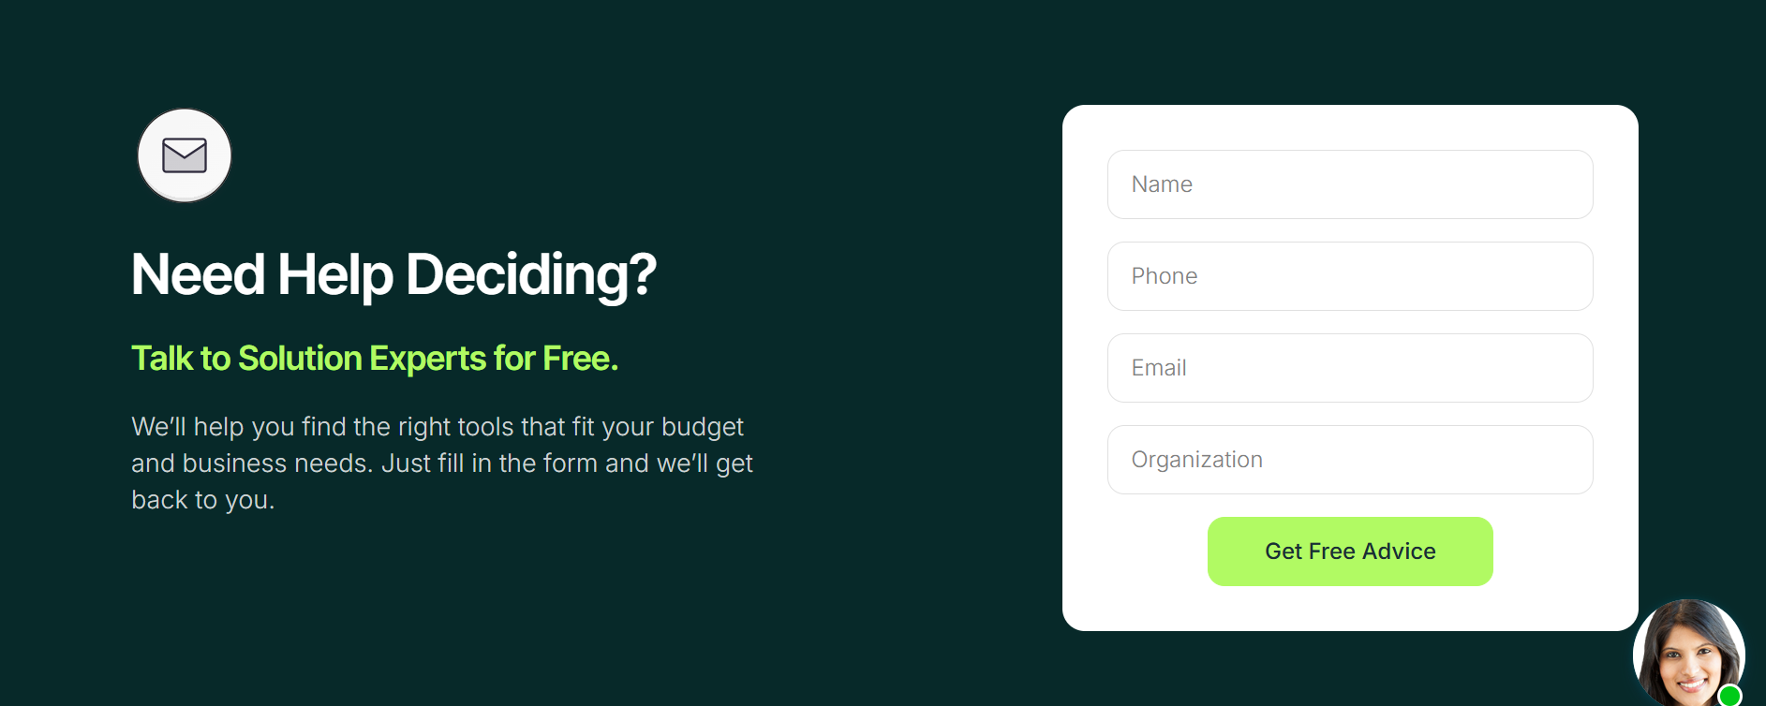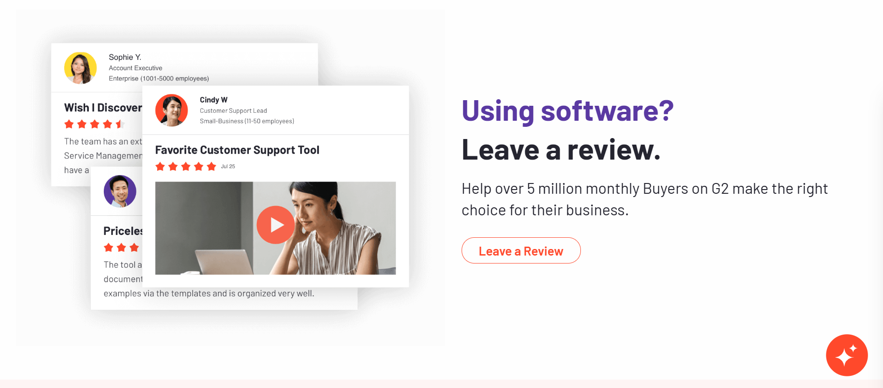

Testimonials Section
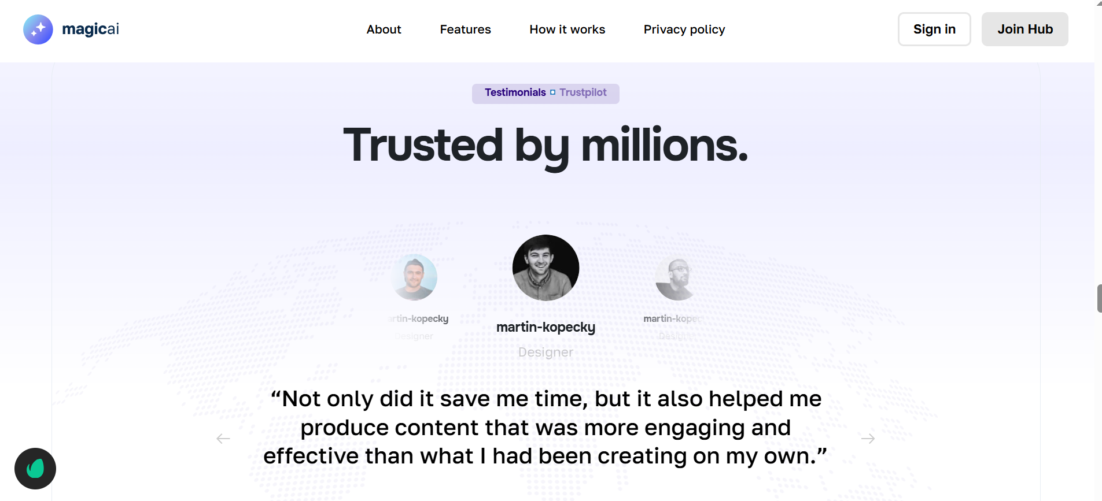
- Will hide the pricing section.
- FAQs section would remain the same.
- Blog section would also remain the same.
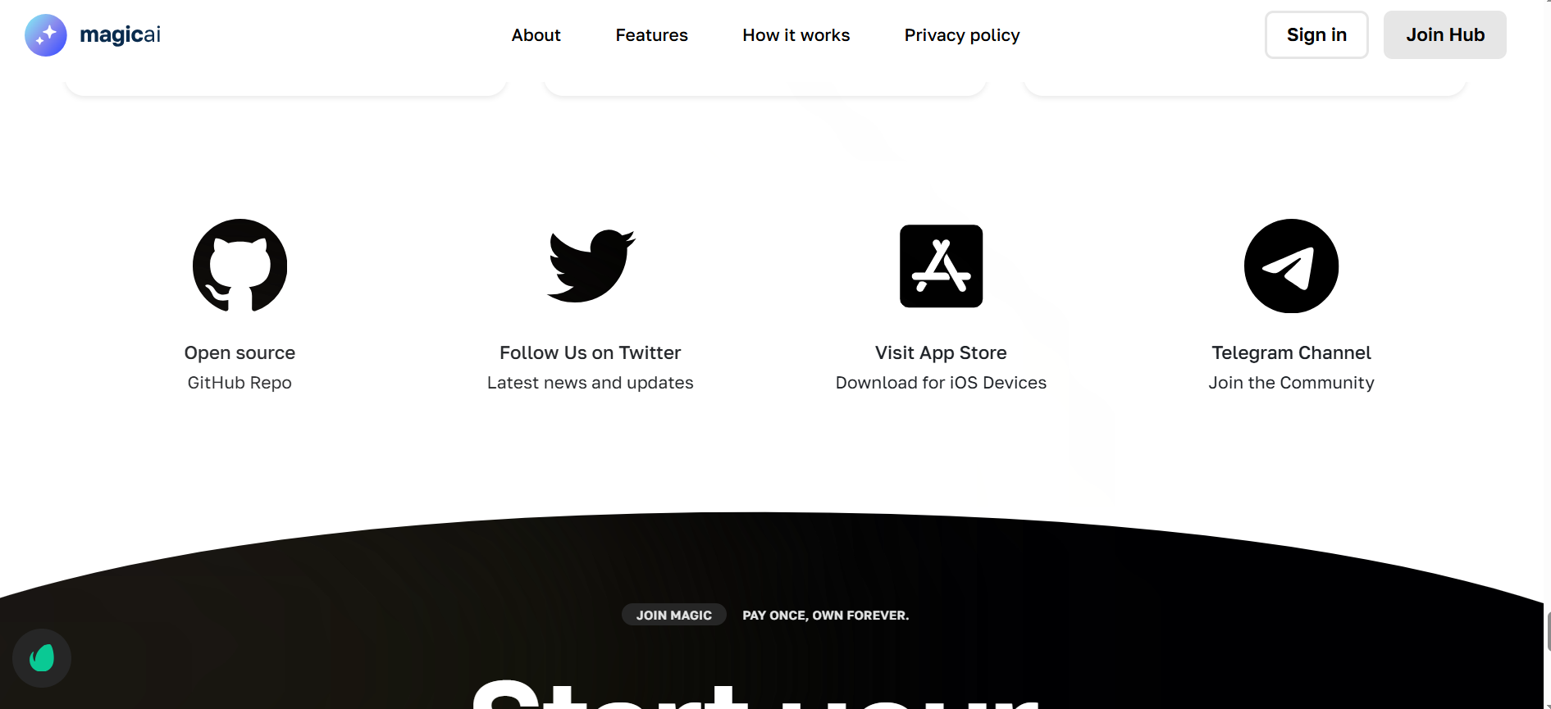
- Let’s delete this section as well.

Footer
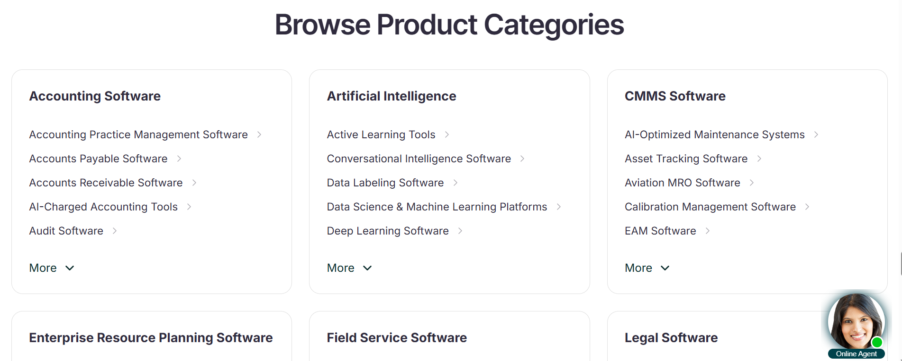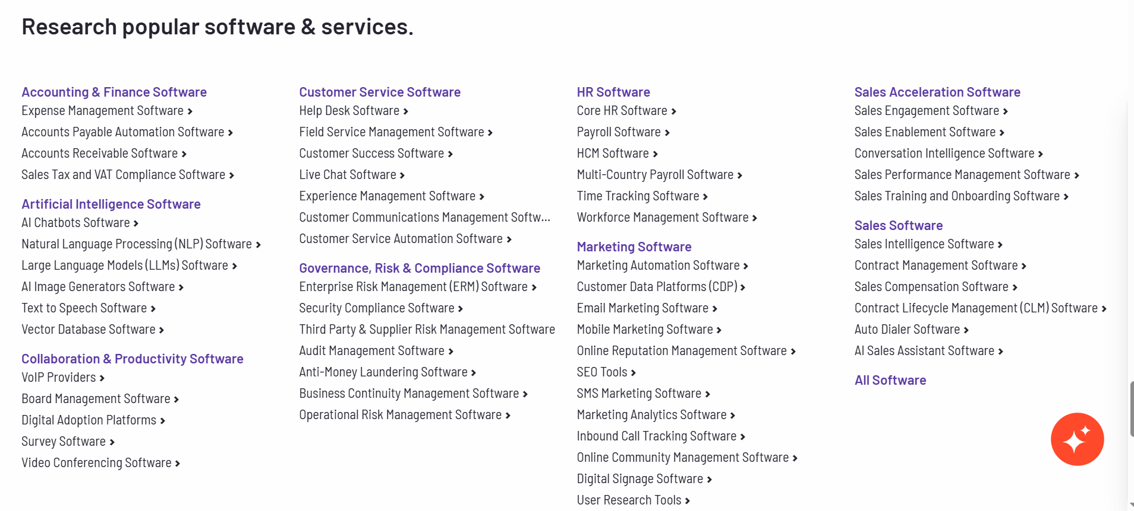


- We would probably wanna change this section to add the product categories similar to how G2 and SoftwareFinder has done. Please check their websites for reference.

Listing main page
- Clicking on the broader category would open a page similar to G2 where we would list the top 4 - 6 software across every sub-category. Something like this: https://www.g2.com/categories/marketing

Our sub-category listings pages would be similar to these:
- https://www.capterra.com/it-management-software/
- https://www.g2.com/categories/project-management

Under the heading and H2, we would add some descriptions of the category. For SEO purposes.
- We want to create filters for search software. Here are snapshots of how our competitors have done it: 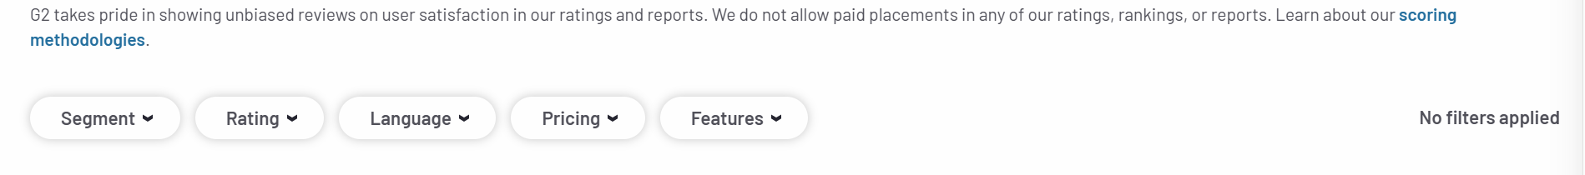
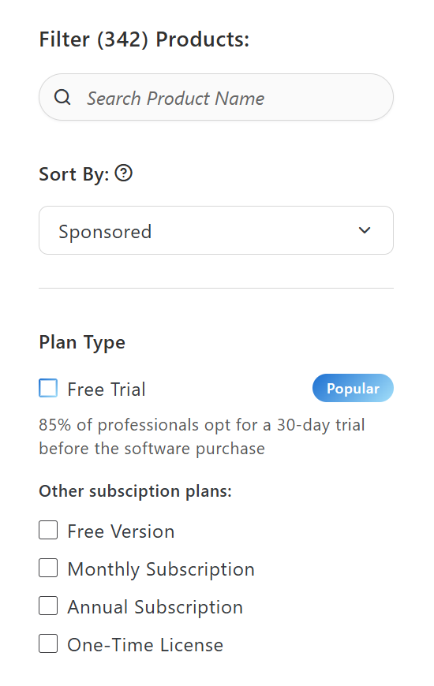
- We want to highlight some of the software (sponsored ones). Something similar to what G2 is doing but will choose different categories. Here is a sample:
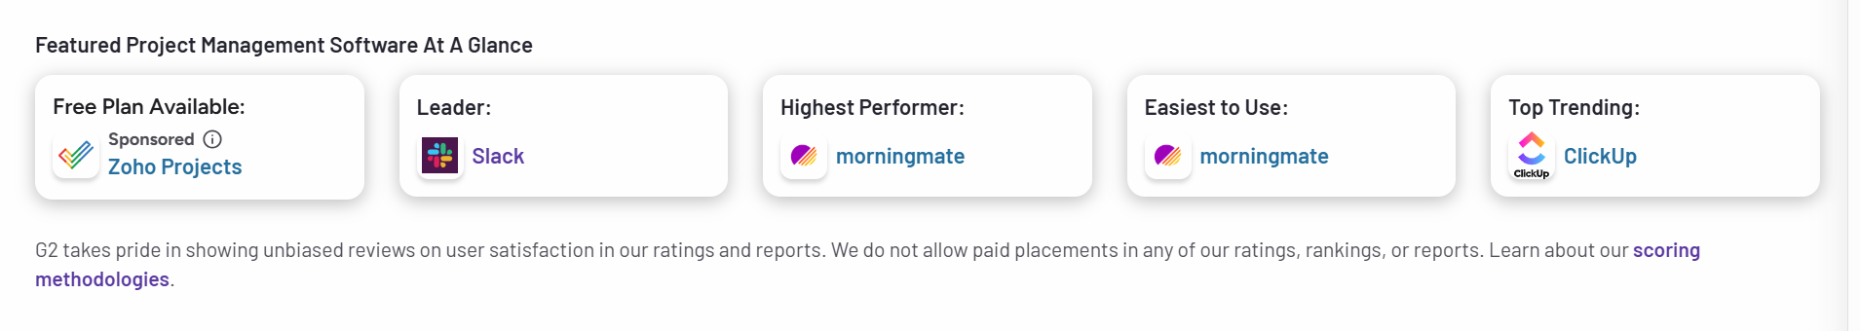

Categories Cards on the listing page
- Here are examples of how our competitors have done it. We want to take inspiration but don’t wanna copy. Let’s please come up with our own design. (Please check softwareadvice, softwarefinder, and G2 for reference).

- 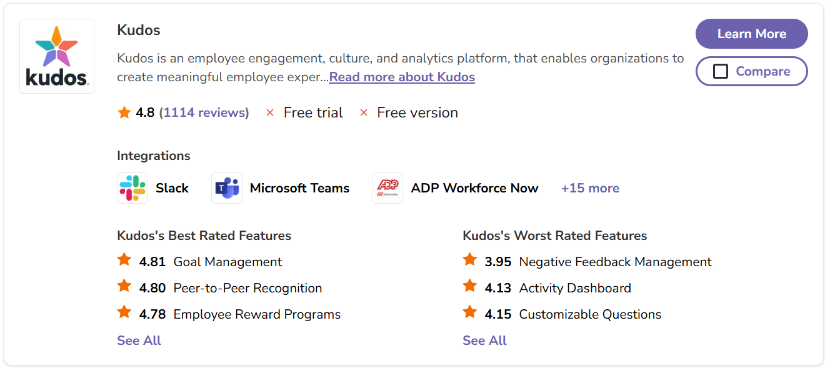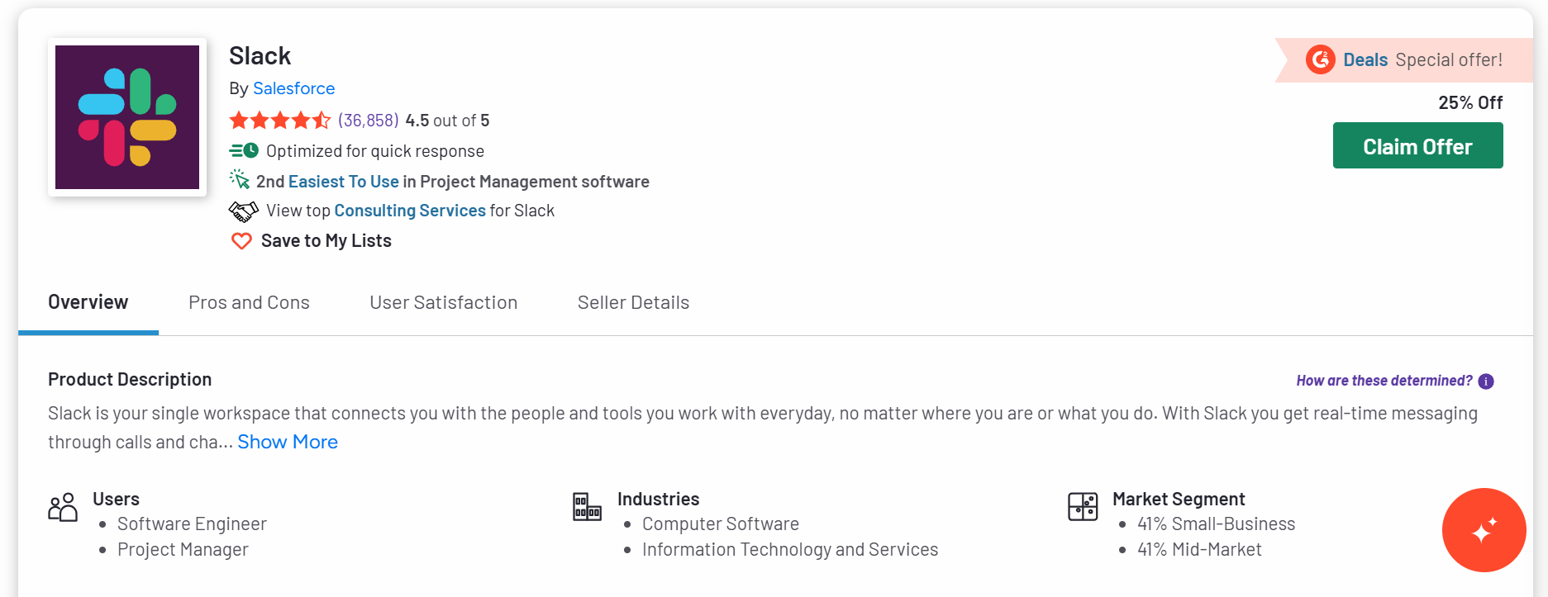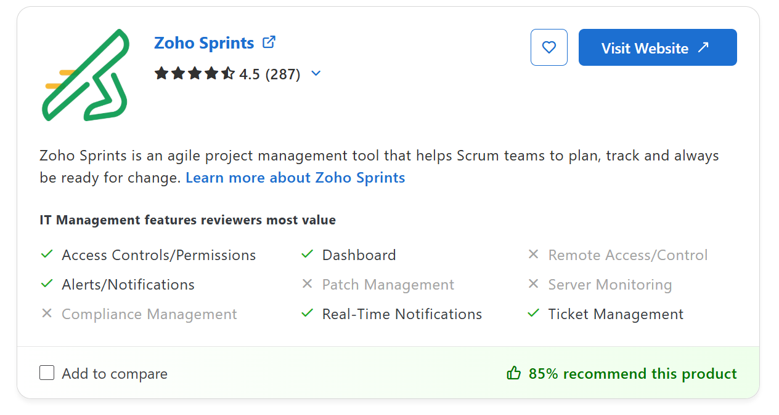
Ok so now here is the information we wanna show on our Listing card:
- Name (It should be clickable and open the detail page of that listing), logo, website URL (button to visit the website). Rating, any badges that it might have earned from us, option to compare, verified or claim your software button, end users, industries, market segment/company size, integrations, highlighted features, information on free trial, satisfaction score (Create our own criteria), whether its for individuals, businesses, teams or what.

Listing detail page

Software Listing Page
References
- https://www.capterra.com/p/169569/Zoho-Sprints/
- https://www.g2.com/products/slack/reviews
- https://softwarefinder.com/artificial-intelligence/labelbox-software
- https://www.softwareadvice.com/product/83223-Kudos/
- https://marketplace.atlassian.com/apps/1228867/it-assets-license-asset-management-for-jira-jsm-itsm?hosting=cloud&tab=overview

We will have tabs/headings/sections and they would be as follows:
- Top block (Information similar to the listing card). Here is an example from Atlassian.

- We have the option to show the tabs either of the 2 ways. For example, check Capterra, g2, software advice, software finder, and atlassian. Here are the snapshots (I love the atlassian one):
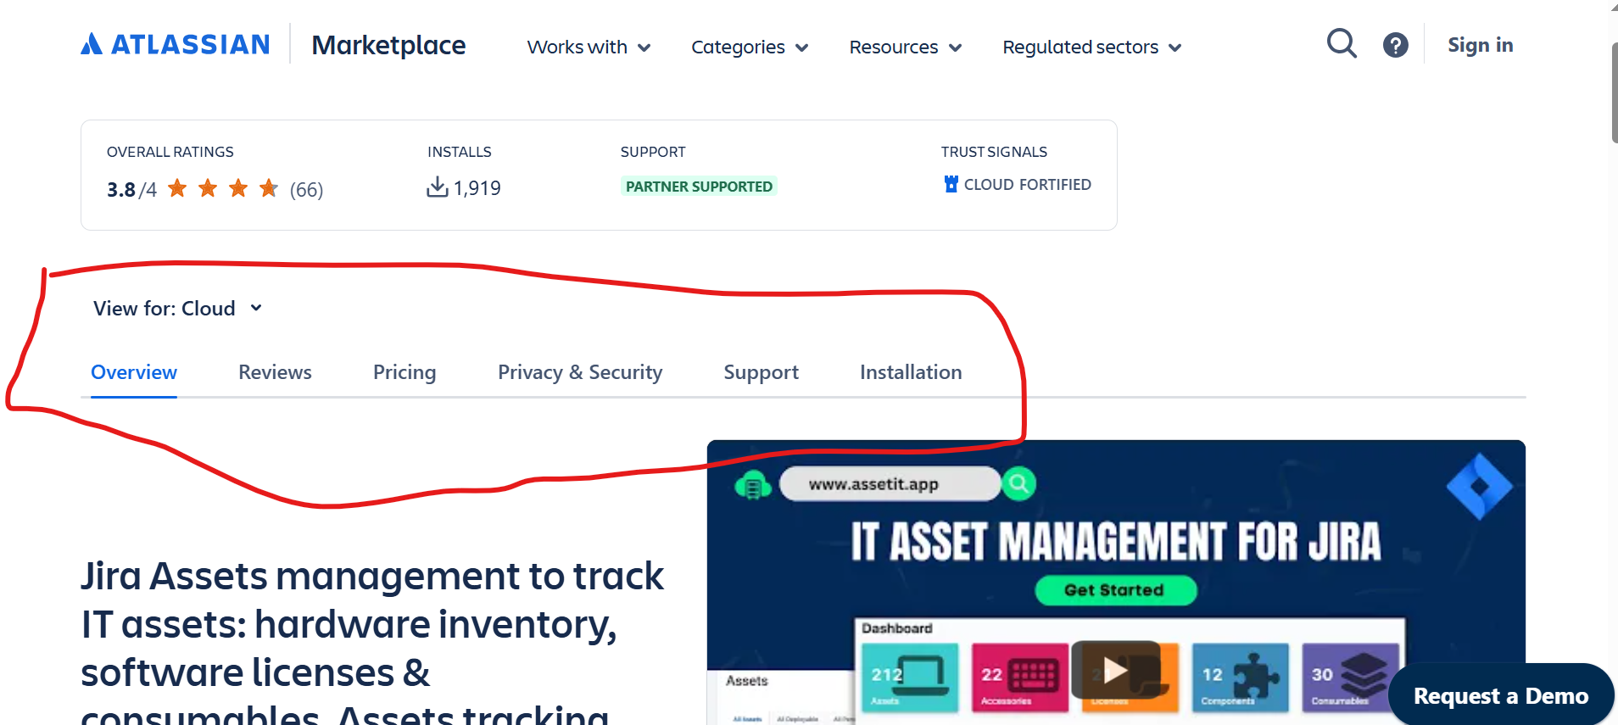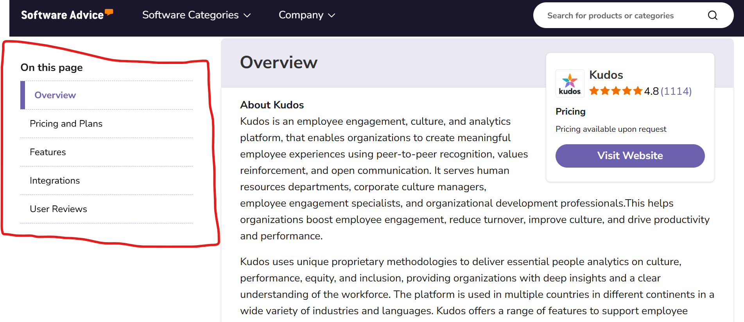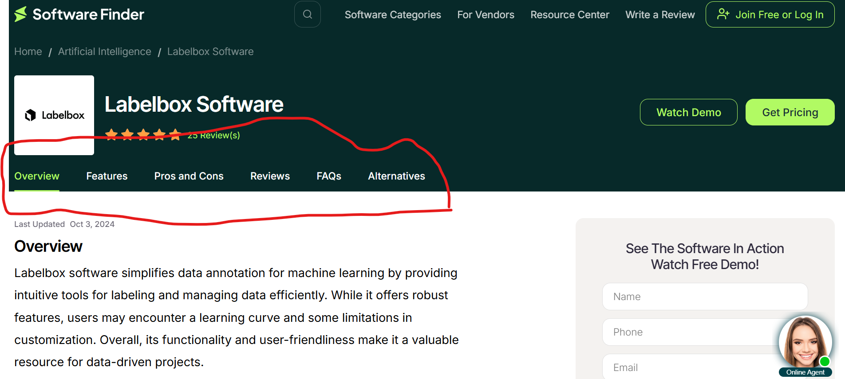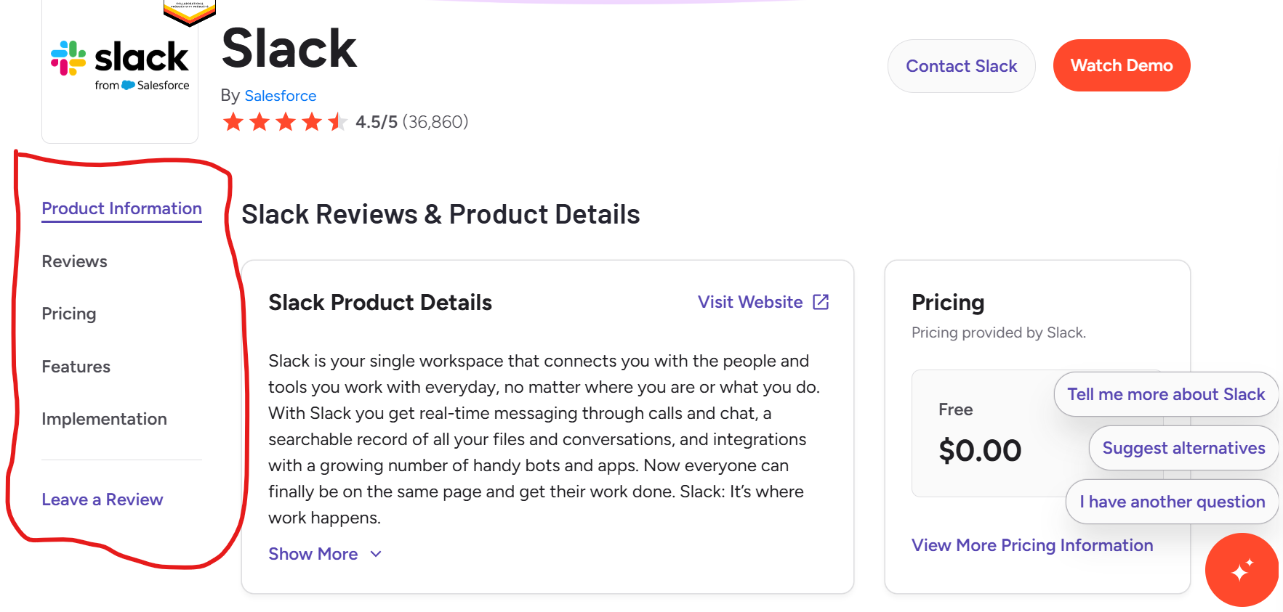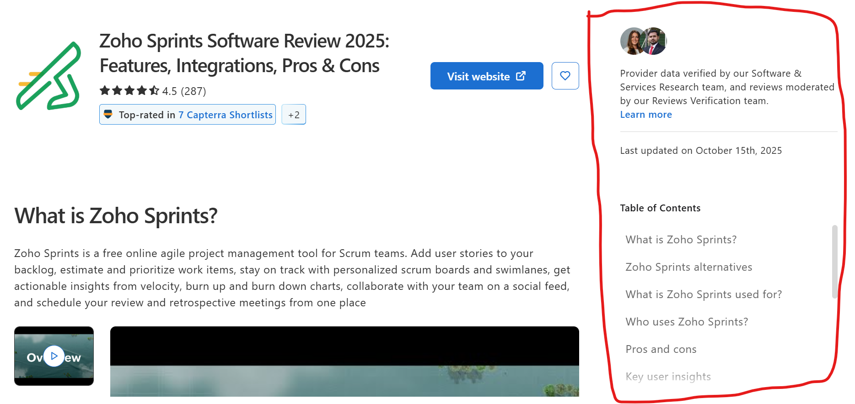
- The tabs we want: Overview,

Development Details

Vendor Workflows

Claim your Product Workflow
- We want our vendors to first sign up with us. They should be able to do so via a company email address. We will then display a form with the following fields: Name, Company Name, Designation, Department, Company Size, Phone Number, and Company Website. We want this form to be a one-pager. If someone clicks on ‘Claim your Product’ or ‘Submit a Product’ or ‘Leave a review’, they should have to sign up first, create their login credentials and then they can have an account. Here is a sample from Software Finder:
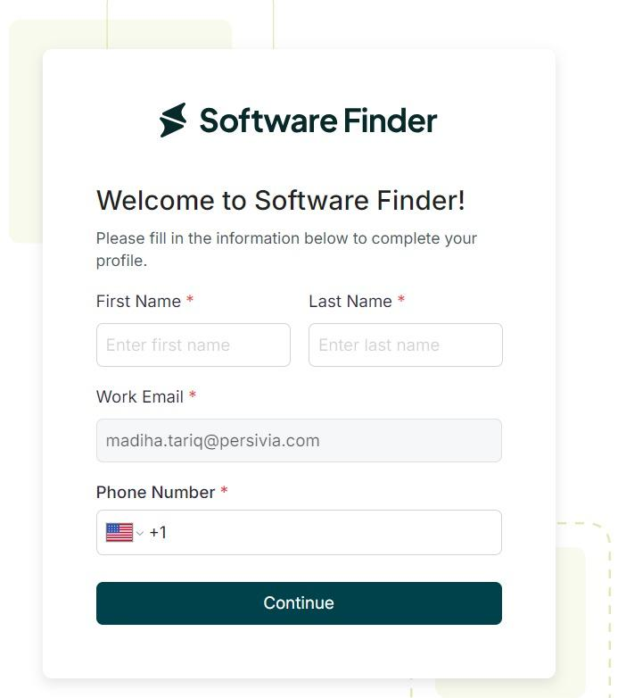
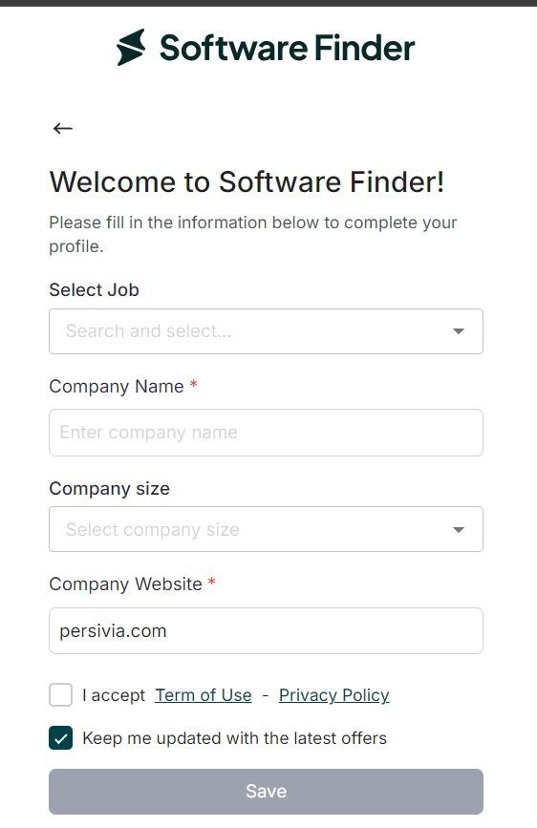
We prefer our form to look like this: (example is Gartner)
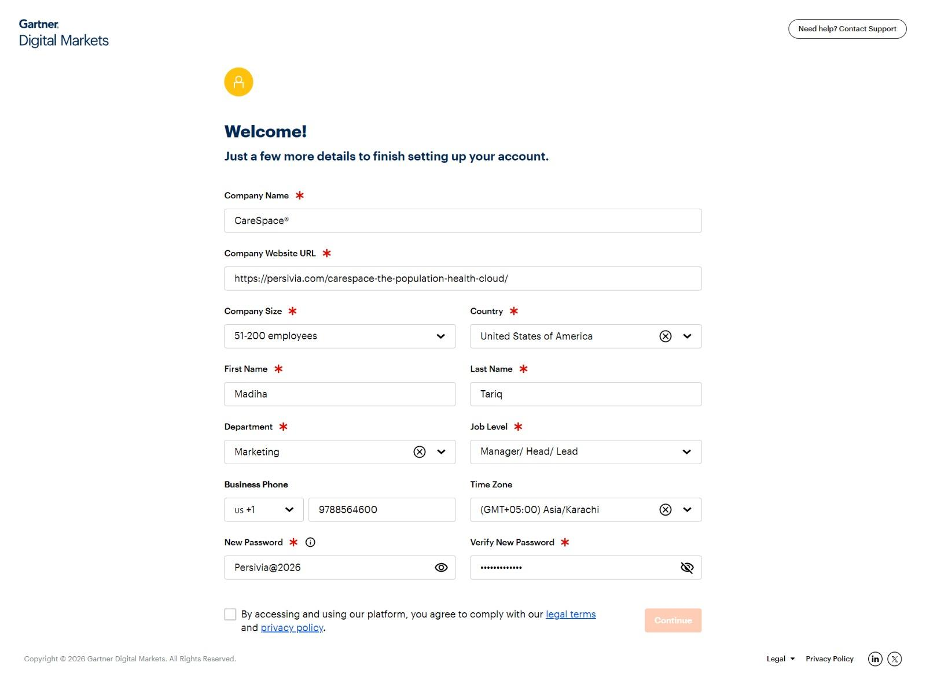

- Once they have signed up and logged in, initially they should be able to ‘claim your product’ or ‘submit a software’. Here is a workflow for ‘Claim your Product’.
- There should be a new page/form where there are numbers of software listed (in grid view). There should be a search bar at the top so vendors can search for the relevant product. Here is an example:
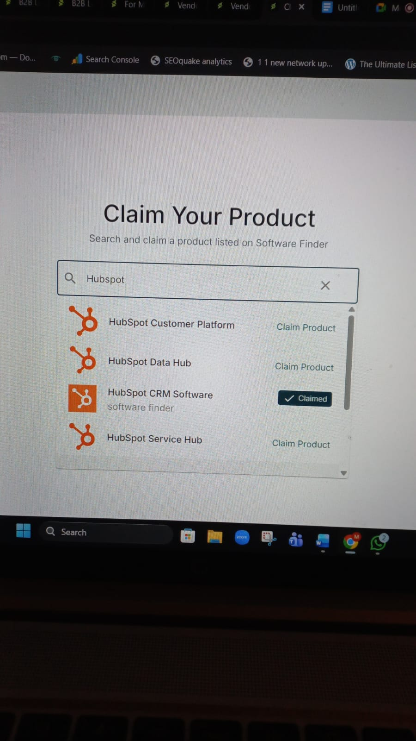
NOTE: If they cannot find the product, there should be an option for them to ‘List their Product’. Here is a sample:
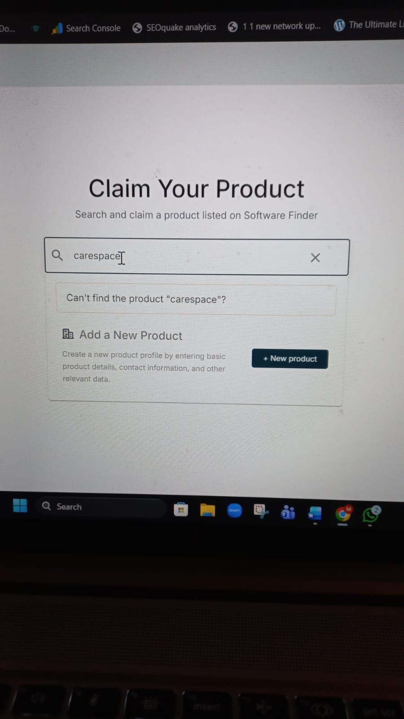
Here is another example of ‘Claim your Product’ and the form that is needed:
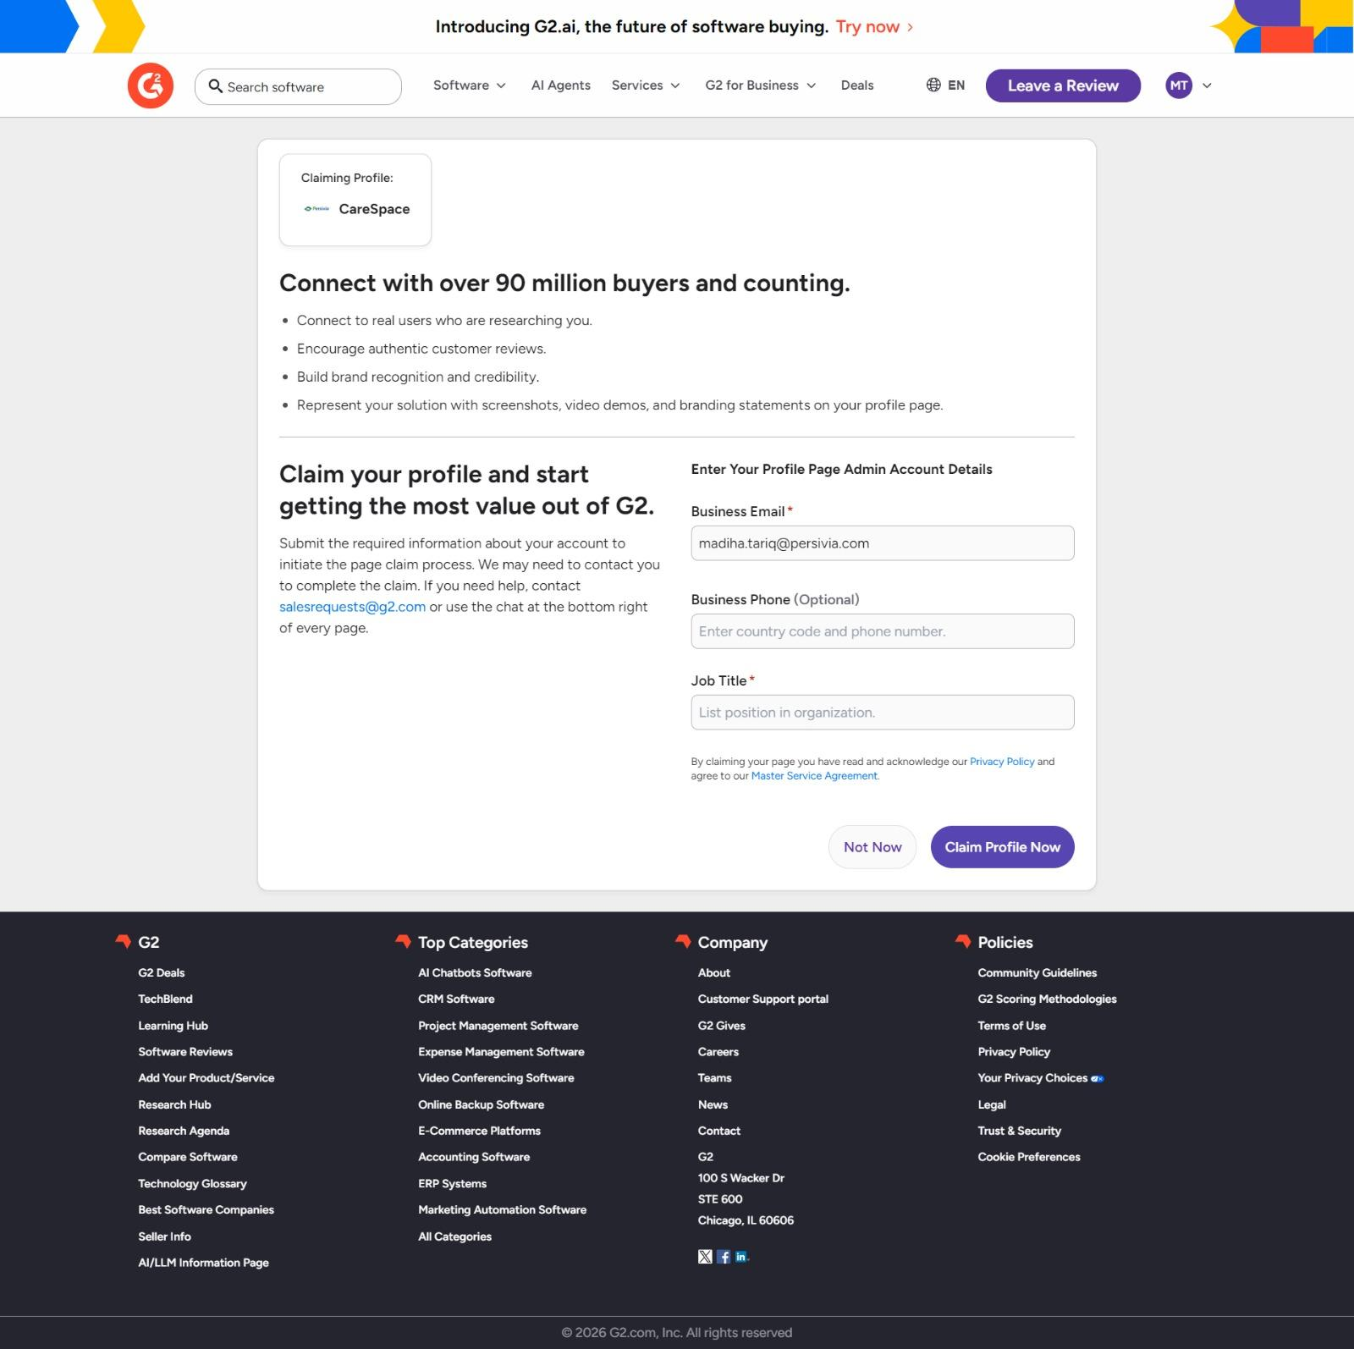

- If they find their relevant product and want to claim it, they should be able to do so by submitting their business email. If it matches with the product email, it would be approved. G2 automatically approves it, let’s see if we can create an automation easily. Otherwise, the claim would be submitted and a push email would be sent to Admin (us) and the Vendor and once we approve it, the profile will be claimed. Another email will be sent to the vendor once their product is successfully claimed. Here is a sample from G2:
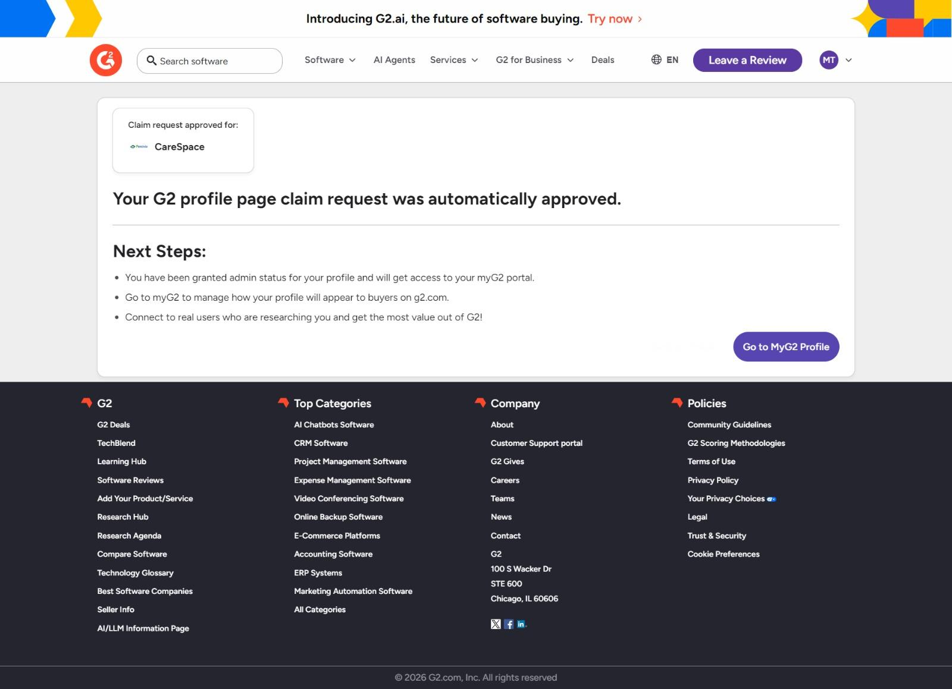
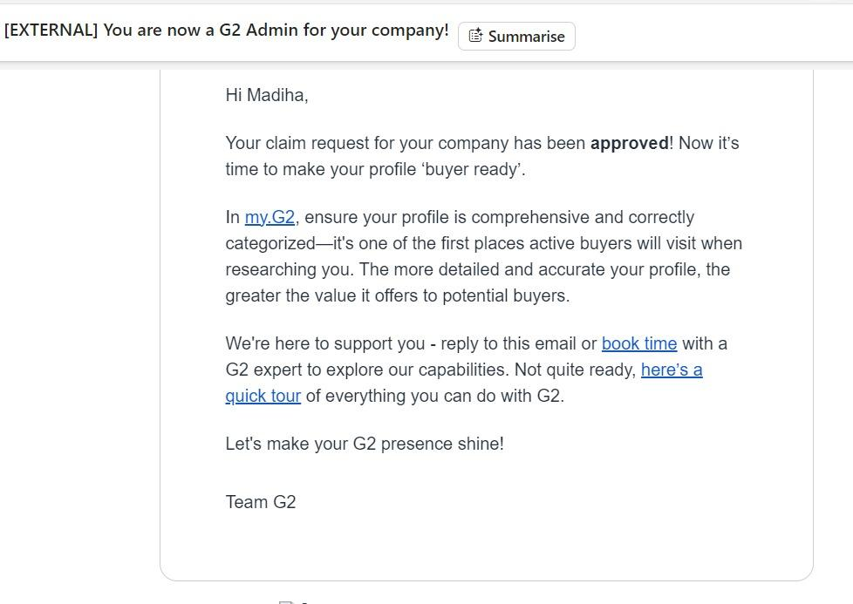
- Once the profile is claimed, there should be options to upgrade the listing. For example, they should be able to add integrations, list features, pros and cons, overview and description updates, pricing details, book a demo, upload screenshots and videos etc etc. All that should be behind a gated payment thing. Here is an example from G2:
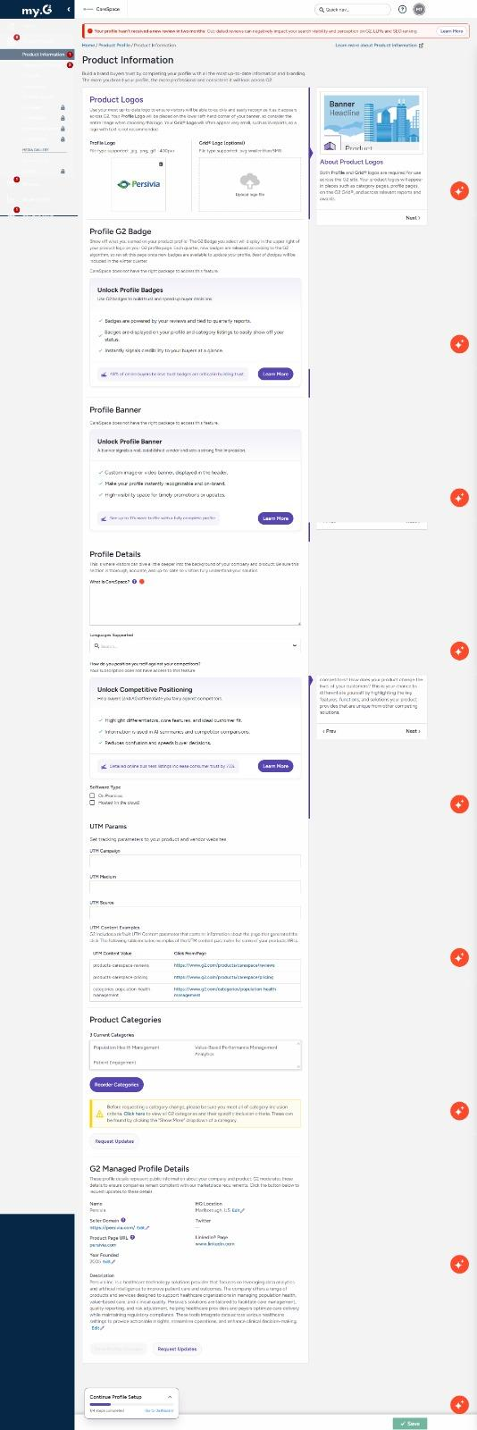
- Whenever a vendor wants to update all these things, they should be redirected to pricing plans. Here is an idea as to how software finders do it (we don’t love it). We want to create tiered pricing. The user can choose to their liking and the features would be unlocked based on their package. We also want to give them an option to send an email to our support and also, schedule a call with our agent.
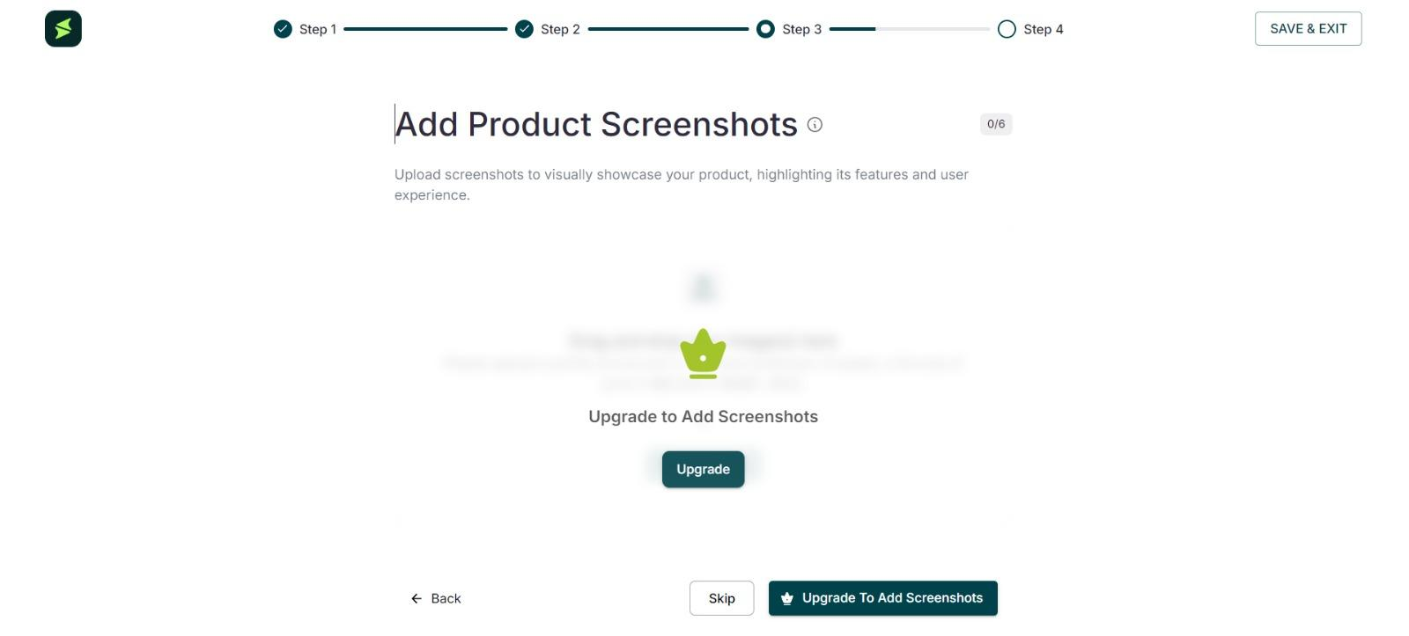
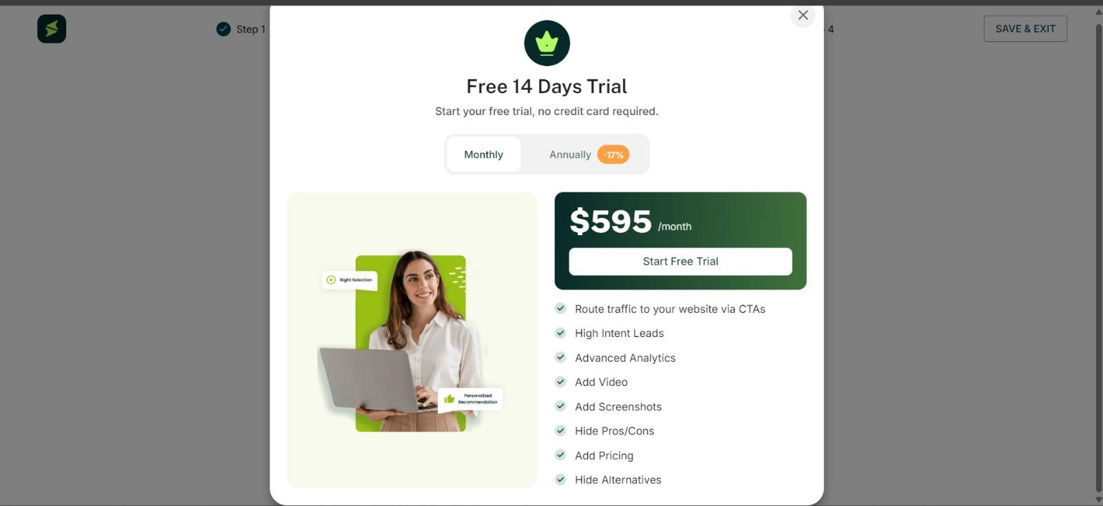
NOTE: We don’t like the multiple screens in the Software finder. We want less steps/screens. Basically it should be more user-friendly.
- Following is a much better way to show what vendors can do with an updated profile. Like a side nav-bar and then allowing them to update basic information (logo, meta description, product name etc). But then blurring out the rest or locking it out while showing all the things they will be able to do once they unlock the features. Here are a few examples:
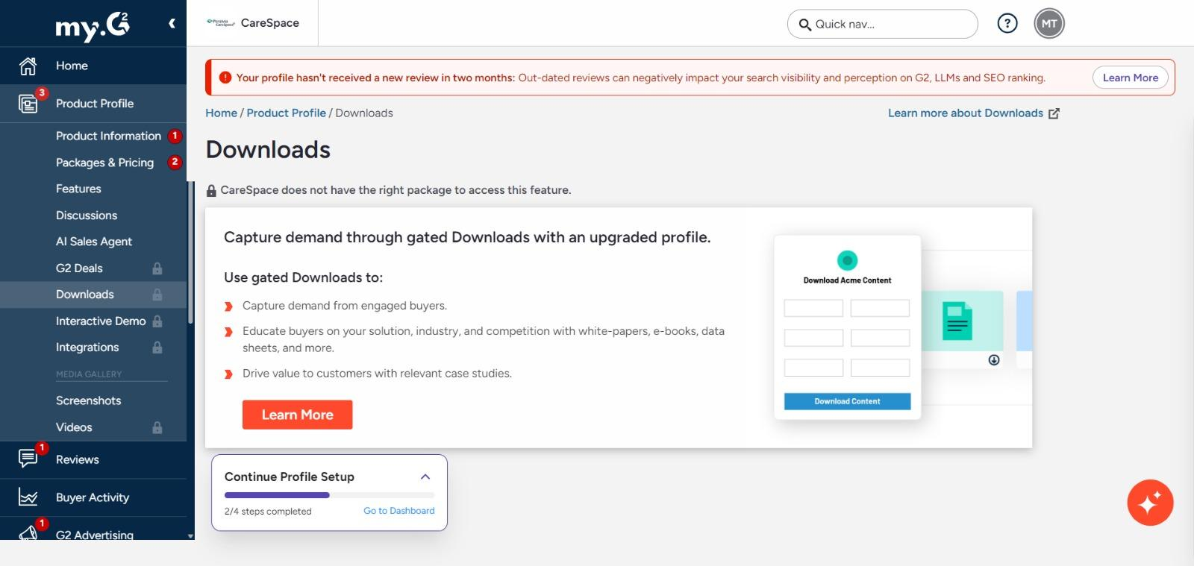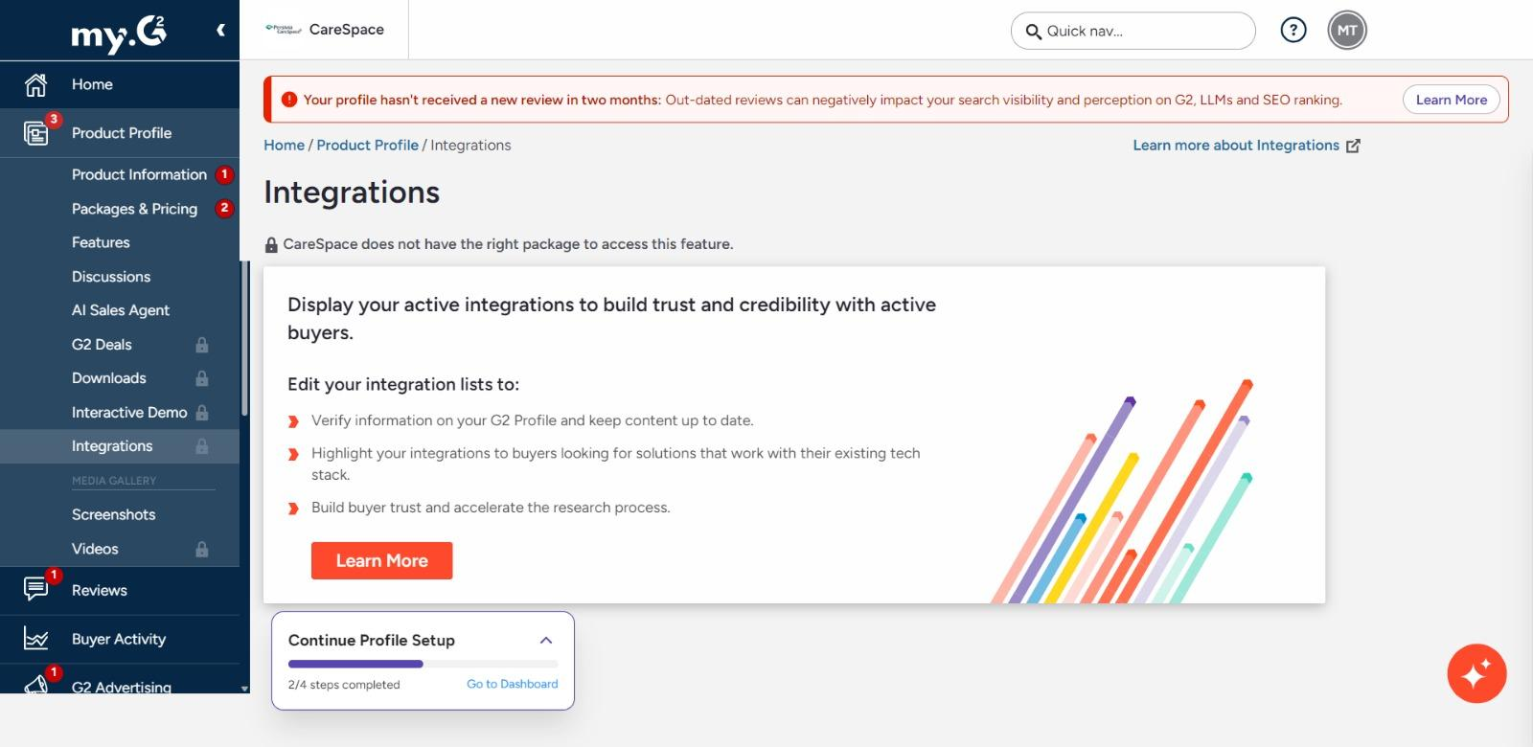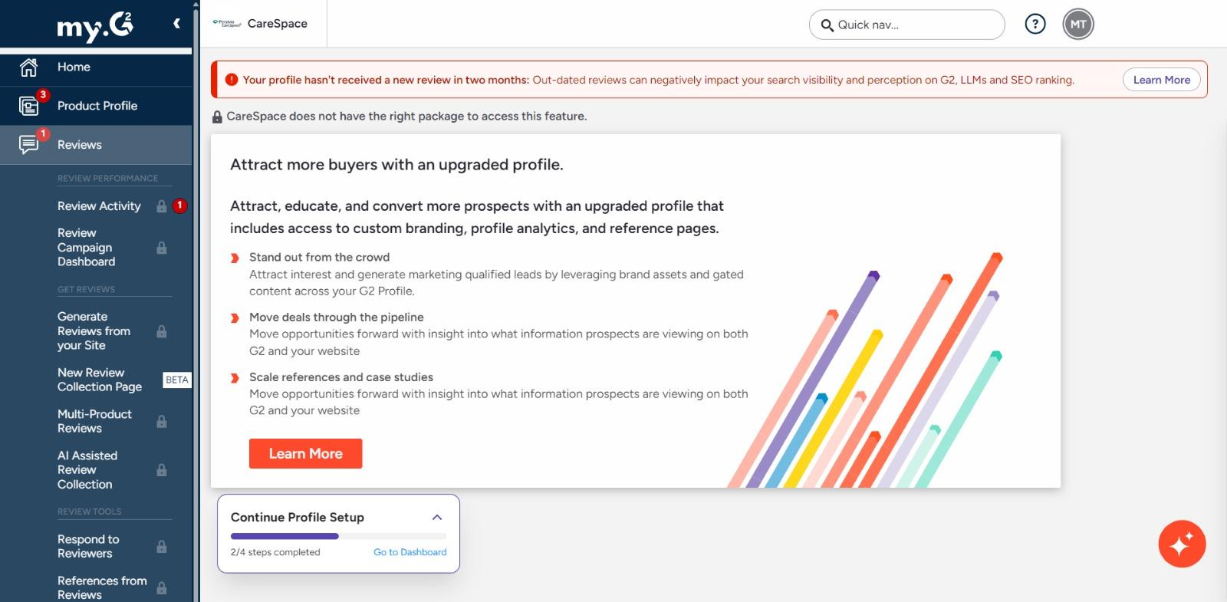

Submit/Register a New Product
- Once the Vendors have logged in to their accounts or if they click on ‘Submit a new product’, they should be able to do so after signing up with us. Here is a preferred workflow to submit a product. We have used the sample from Gartner.
- We want to start with giving them a guideline of what sort of product to list. They have to specify if it is a b2b product or a b2c product. And we have to give a disclaimer that the product should be AI-focused. Something similar to this:
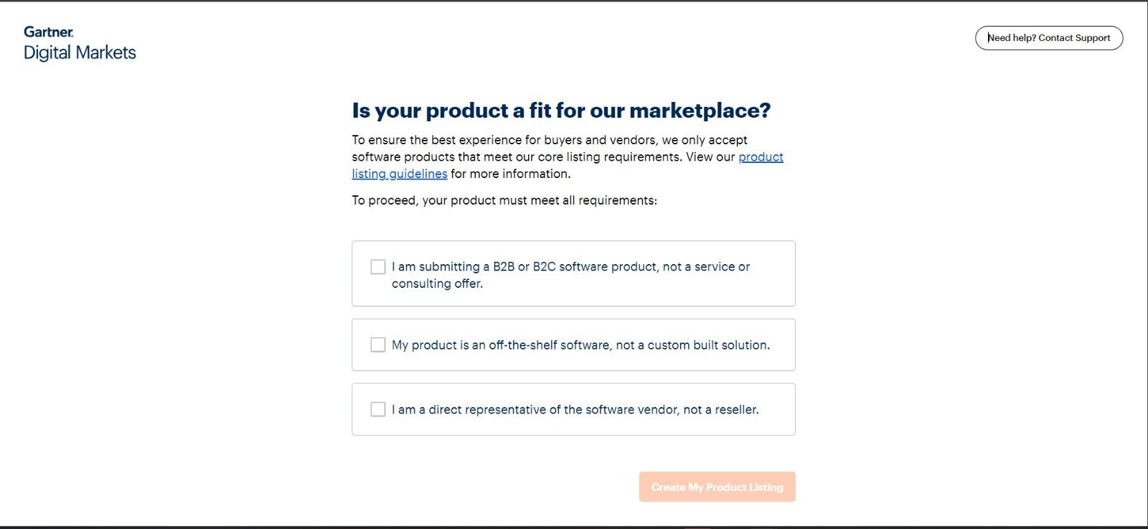
- Then we provide them with a form for product listing requests. Here is an example from Gartner:
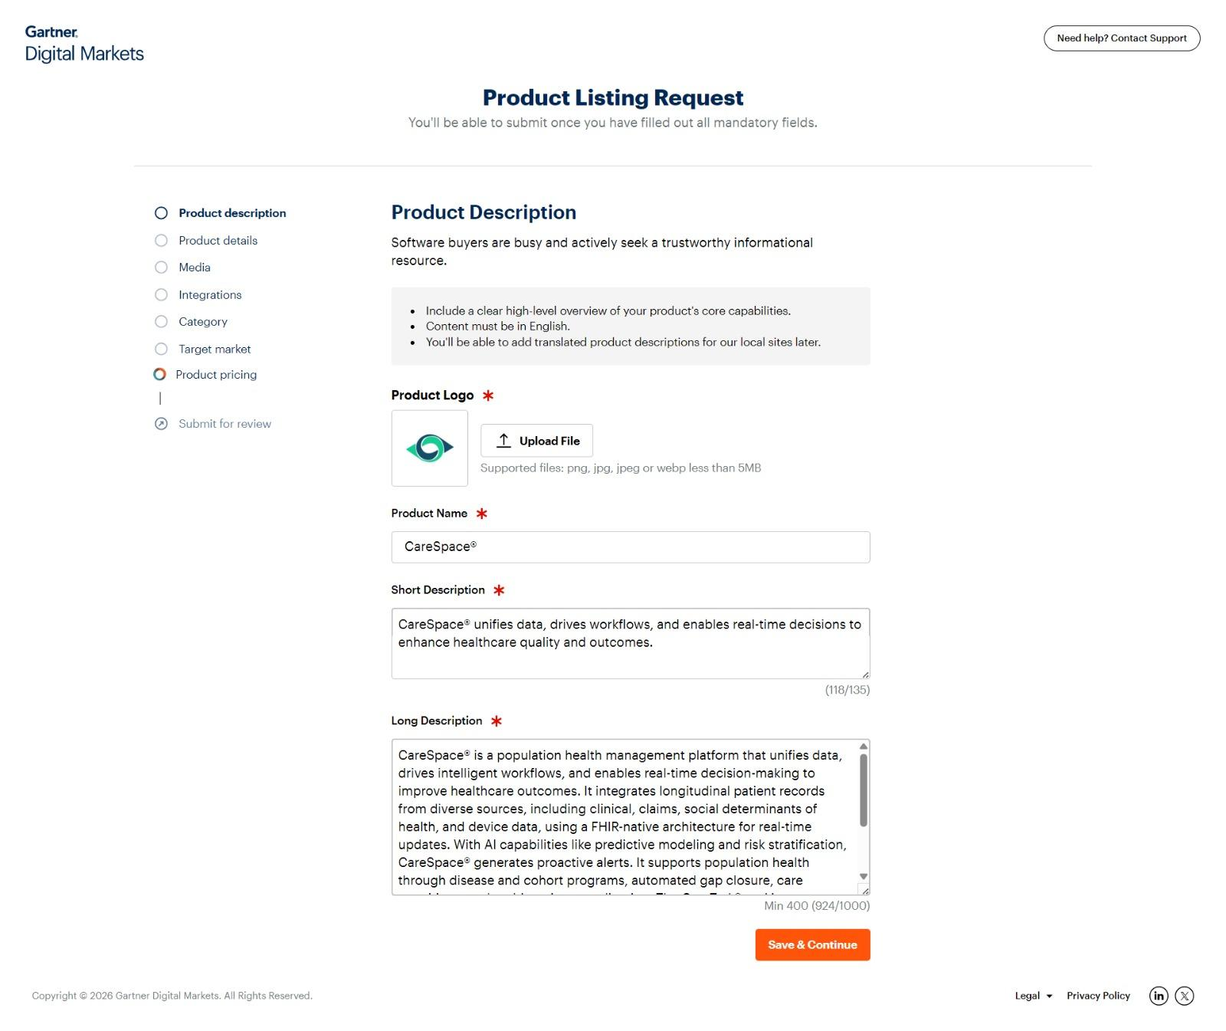
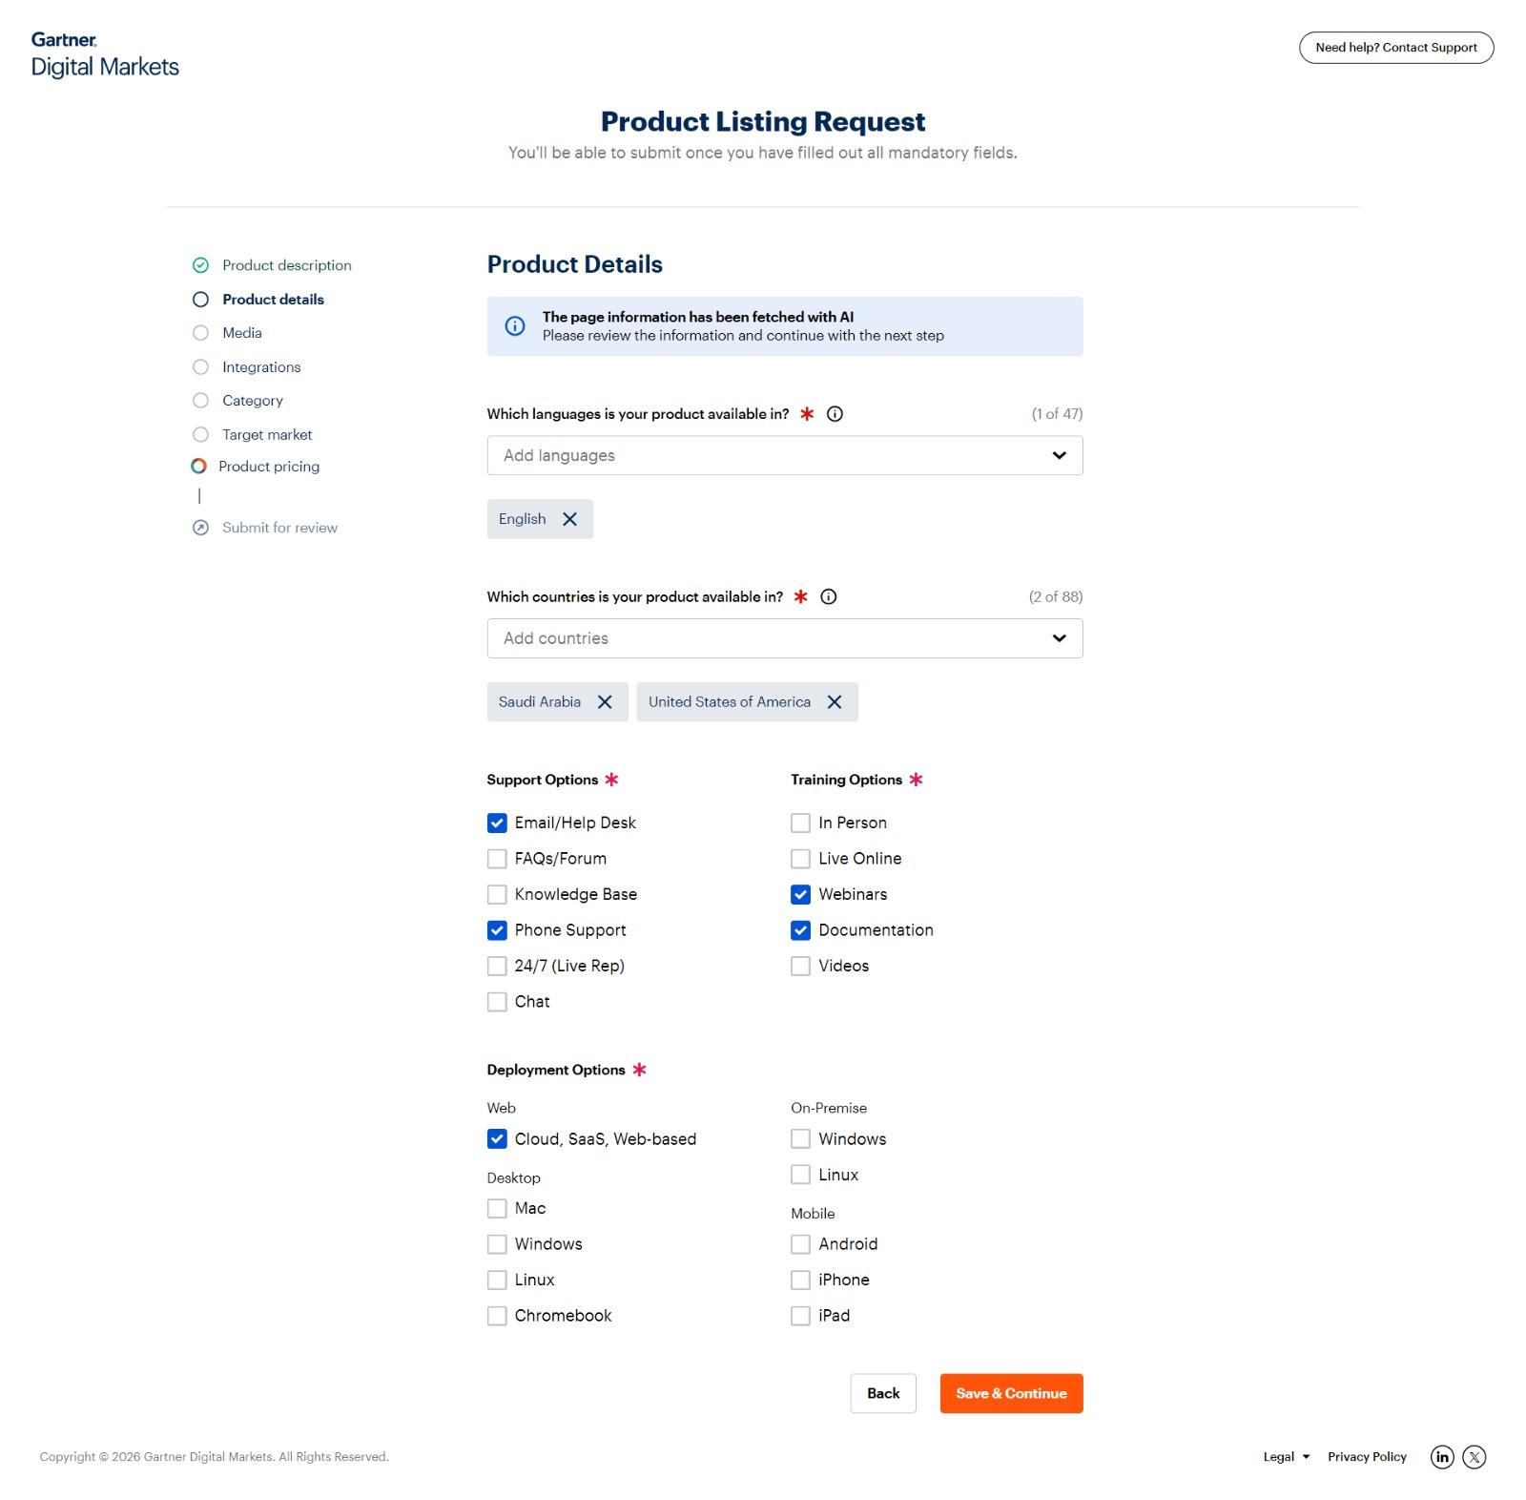
- We will ask them to upload the product name, logo, description/overview, deployment options, software category, subcategory, end user personas, target market company size, and then they should be able to review their submission, make edits and finally submit for review. Here is an example of the screen:
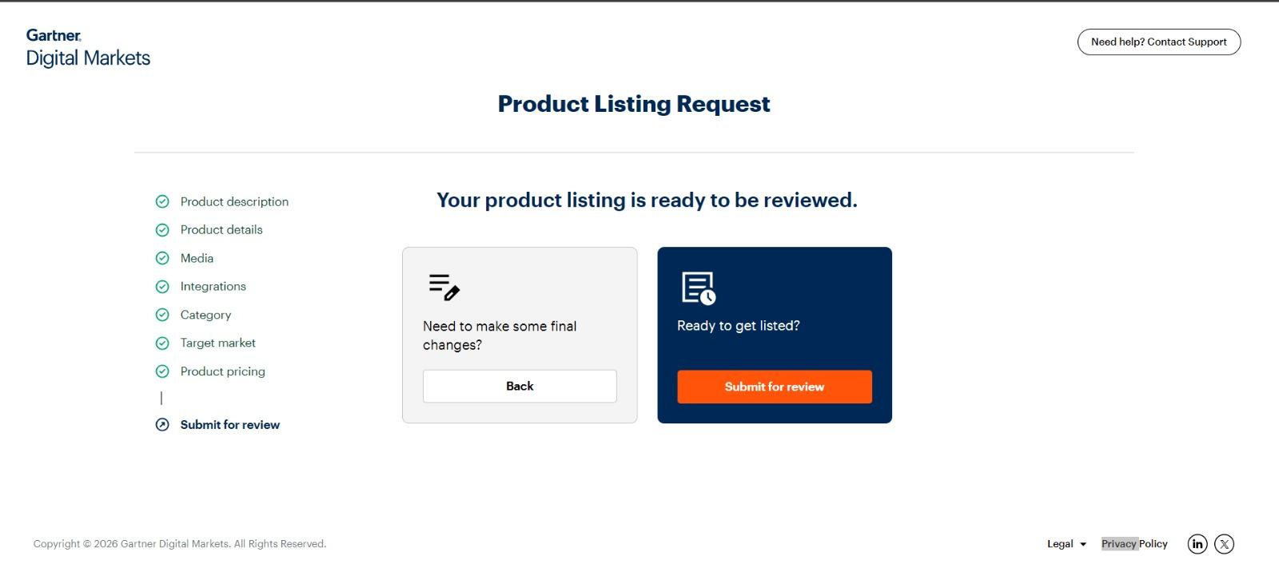
- They should get an email once they submit for review. We should get an email too. We’ll review and publish. They should get an email that their submission is now live. Once their submission goes live, they should get a portal where they can unlock further features by subscribing to a plan.

Submit a Review Workflow
- Whenever someone clicks the ‘Leave a review’ CTA, they should be redirected to a page where they have to sign-up. The following is an example of how G2 goes about it. It's quite lengthy and tedious. We want it to be simple (a single screen or max 2 screens.)
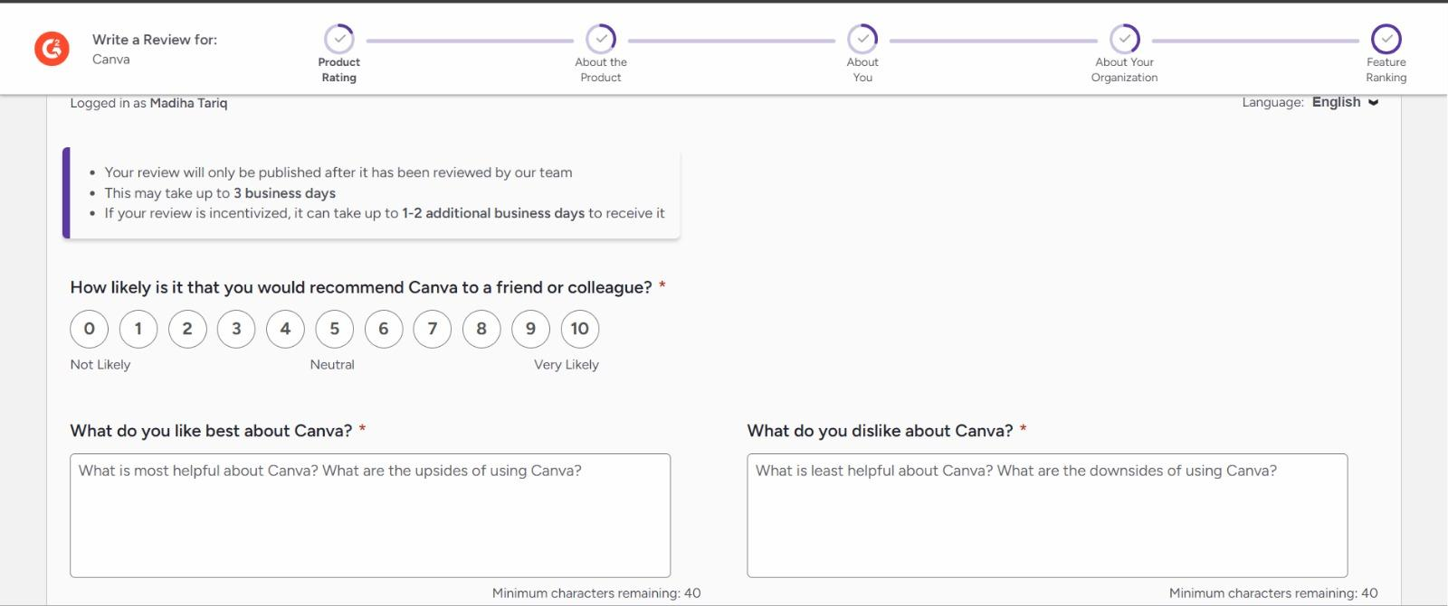
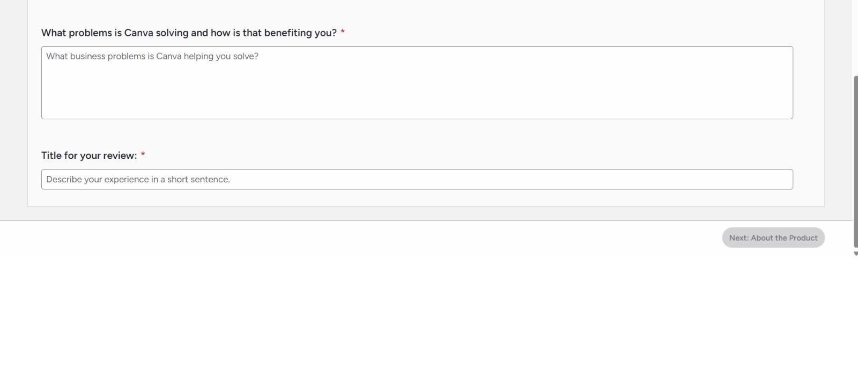
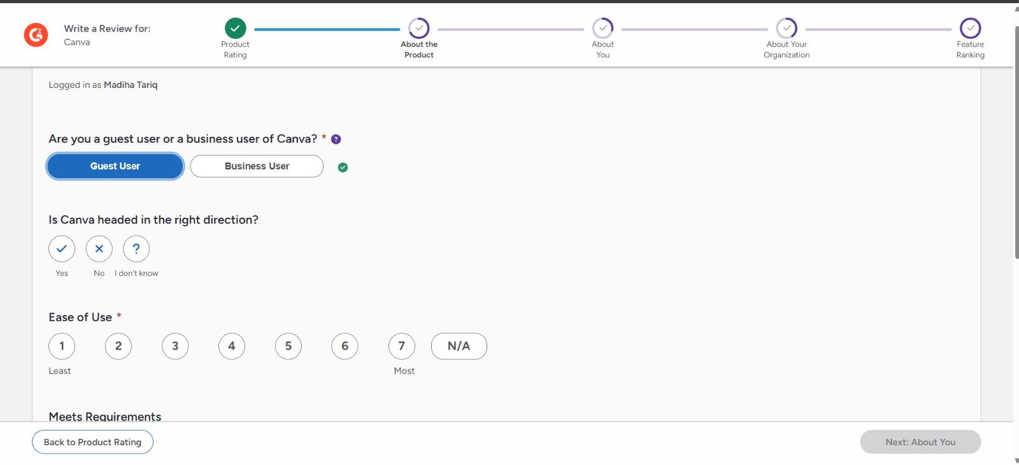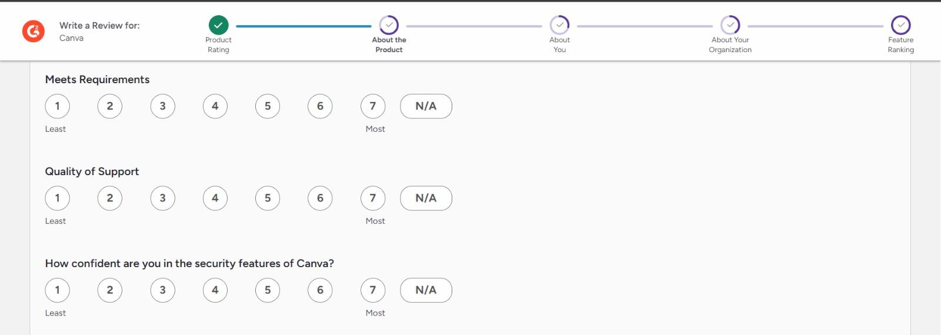
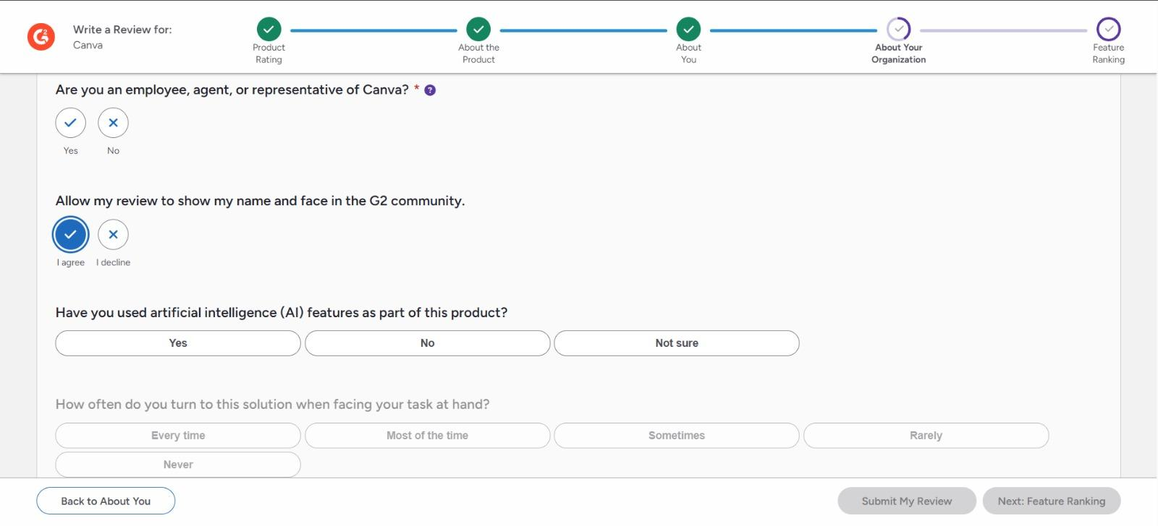
- Ok so the details we would want for review would be title of the review, description, and then similar to G2, we will come up 1-10 ranking for a couple of questions. We will then take average and rate the product (automated). For example, we would wanna know ease of use, how much business value it adds, if it is saving them money, quality of the support, suite of feature satisfaction, feedback loop, etc etc.

NOTE: We want all software listings to be tagged by categories, subcategories, industries, end users. Every software can be listed in multiple tags. There should be a list for categories to choose from but there would be an option of OTHERS if the category is not listed. and if they choose another, there should be a field for them to specify. For industries, they should be able to choose multiple industries and suggest new ones, too. Users should be able to choose multiple categories too.

PRD Document

Product Requirements Document

1. Product Overview
Product Name: Techanalytica
Product Type: B2B AI tools directory + editorial + vendor marketplace
Core Purpose: Help professionals discover, evaluate, and understand AI tools for work
Secondary Purpose: Provide visibility + distribution channels to AI vendors
V1 Lens: Marketplace + media hybrid with monetization

2. Problem Statement
Businesses want to adopt AI tools but discovery is fragmented, hype-driven, and shallow.
Professionals struggle to filter through thousands of tools that feel similar with unclear differentiation.
Vendors struggle to get qualified visibility, especially newer or niche AI tools.
Current ecosystems (Futurepedia, Toolify, Product Hunt) lack depth, credibility, editorial analysis, and structured buyer-assistance.

3. Value Proposition
For buyers / professionals:
- Discover relevant AI tools quickly
- Compare by category & industry
- Understand use cases and pricing
- Benefit from editorial context (blogs, insights)
- Shorten AI adoption decision cycles
For vendors:
- Gain visibility
- Acquire credibility via structured listings
- Access performance insights (analytics)
- Purchase sponsored placements
- Reach early adopters + enterprise buyers

4. Target Users / Personas

(1) Professional Buyers
Examples:
- IT leaders
- Product teams
- Marketing & Sales leaders
- Ops & CX teams
- Founders & startup teams
Needs: clarity, trust, categorization, pricing, use-cases

(2) Vendors (AI Tool Creators)
Types:
- PLG SaaS startups
- Enterprise AI vendors
- Consulting/solution firms
- Niche AI tools (emerging)
Needs: visibility, traffic, distribution, credibility, analytics, editorial coverage

(3) Editorial / Admin
Internal users managing:
- Categories
- Listings
- Submissions
- Pricing
- Blogs
- Featured placements
Needs: control, curation, quality, monetization ops

5. Product Goals (V1)
- Create a structured directory of AI tools
- Enable vendor claims + submissions
- Enable paid monetization via:
  - Sponsored placements (duration-based)
  - Listing upgrades (tiers)
  - Paid analytics
- Launch editorial content to build authority (blogs)
- Provide functional CMS for internal operations

6. Non-Goals (for V1)
- Reviews/ratings system (deferred)
- PPC/CPL monetization (deferred)
- Affiliate revenue (optional V2)
- API-based listing ingestion
- Deep lead gen routing
- Cross-vendor comparison engine
- Recommendation engine
- Multi-CTA
- Use-case tagging
- Slot-based sponsorship auctions

7. Competitive Landscape (Short Scan)
Direct-ish competitors:
- Futurepedia (high volume, low depth)
- Toolify (directory + trending)
- Product Hunt (launch platform)
- Software Finder (sponsored placements)
- Capterra (reviews + CPC)
- G2 (reviews + enterprise)
Weakness of competitors:
- No editorial insight
- No buyer enablement
- No industry specificity
- Few enterprise use cases
- Little taxonomy depth
- Vendor monetization early, but shallow
- No credible analytical lens
Techanalytica wins on:
✔ depth
✔ credibility
✔ editorial authority
✔ mapping to real business functions
✔ enterprise-friendly structure

8. Differentiators

Functional
✔ Categories structured by business function
✔ Industry overlays
✔ Editorial analysis
✔ Vendor dashboards
✔ Paid analytics
✔ Configurable CTA types
✔ Free base listing + paid visibility

Emotional/Brand
✔ credible, analytical, non-hype
✔ enterprise-oriented
✔ discovery + education combined

9. Success Metrics (V1)
Marketplace Metrics
- of listings published
- of claimed vendors
- of vendor submissions
- of paid upgrades
- of sponsored placements sold

Traffic/SEO Metrics
- organic traffic growth
- blog impressions & CTR
- return visits
- time on category pages

Conversion Metrics
- claim -> upgrade rate
- submission -> approval rate
- sponsor purchase rate
- CTA click-outs (premium analytics)

10. Launch Timeline Target
V1 target: 60–90 days
Initial categories: ~50–70
Initial listings: ~700–1,000 seeded manually

11. V1 Feature Scope Summary
Included:
✔ directory
✔ categories
✔ vendor claim
✔ vendor submit
✔ sponsored placements
✔ pricing tiers
✔ claim approval
✔ submission approval
✔ CTA configurable (single)
✔ pricing data
✔ industry tags
✔ video embeds
✔ analytics (paid)
✔ CMS
✔ blogs
Not included (V2):
❌ reviews
❌ use cases
❌ CPC/CPL
❌ lead routing
❌ A/B comparison
❌ rec engine
❌ API ingestion

12. Risks & Mitigations
Risk | Mitigation
Vendor low adoption | free tier + analytics tease
SEO saturation in generic AI lists | editorial depth + category specialization
Quality inconsistency | admin CMS controls
Monetization too early | hybrid free + sponsor model
Operational bottleneck | auto-publish edits; only approve new/claims
Complexity creep | V1/V2 boundary maintained

13. Strategic Outcome
If V1 succeeds, Techanalytica becomes:
✔ a vendor distribution channel
✔ a buyer enablement platform
✔ a media + marketplace hybrid
✔ a trusted AI adoption navigator
Which unlocks:
- enterprise sponsorship
- reporting/analytics sales
- future lead gen
- affiliate
- CPL/CPA
- category deep dives
- data products (long-term)

NEXT STEP
If you approve PRD as accurate, I will proceed to:
✅ Batch 2 — SRS (System Requirements)
which defines:
✔ functional behaviors
✔ states
✔ roles
✔ data validation
✔ constraints
✔ approvals
✔ workflows

SRS Document

System Requirements Specifications

1. System Overview
Techanalytica V1 is a web-based platform with:
✔ Directory + listings
✔ Vendor onboarding (claim + submit)
✔ Monetization (paid placements + upgrades)
✔ Analytics (paid)
✔ CMS (editorial + listings + homepage)
✔ Blog publishing
✔ SEO optimization
✔ Vendor dashboard
✔ Admin approval workflows

2. System Actors & Roles
Role | Access & Capabilities
Public User | browse, search, filter, click CTAs, read blogs
Vendor (Unclaimed) | view listing, initiate claim
Vendor (Claimed) | edit listing, buy upgrades, buy sponsorship, view dashboard
Editor | manage listings/blogs/categories, no billing
Admin | full access: approvals, billing, CMS, sponsorship, pricing
System | auto-state transitions, analytics tracking, cron tasks
Note: Editors exist mainly to scale content operations; not mandatory in early V1.

3. Functional Requirements

3.1 Listings
System must allow:
- Creation (admin, vendor submit)
- Editing (vendor after claim)
- Publishing (admin)
- Featuring (admin, paid)
- Categorization
- Industry tagging
- Media uploads (logo, screenshots)
- Video embeds
- Pricing data
- Configurable CTA (1 type per listing)
- Status tracking
Listing Status States
- Draft
- Pending Review
- Approved / Published
- Rejected
- Archived

3.2 Vendor Claim Workflow
System must allow:
- Vendor to initiate claim
- Admin to verify & approve
- Convert listing to vendor-owned
- Post-claim instant editing rights
Claim Status
- Unclaimed
- Claim Pending
- Claimed

3.3 Vendor Submission Workflow
System must allow:
- Vendor to create a new listing
- Submit for review
- Admin to approve/reject
Submission States
- Draft
- Pending
- Approved
- Rejected

3.4 Editing Rules
After claim:
- Vendor edits go live instantly
- System enforces limits (character count, screenshot count, CTA type, pricing fields)
Admin overrides:
- Admin may suspend or rollback listing

3.5 Categories & Industries
Categories:
- Defined by business function (Marketing, Sales, Finance, etc.)
Industries:
- Overlay tags (Healthcare, Retail, Manufacturing, etc.)
System supports:
- Many-to-many relationships

3.6 Search & Filtering
System must allow:
- Keyword search
- Category filter
- Industry filter
- Sorting by ranking
Ranking = hybrid (editorial + sponsored + recency)

3.7 CTA Behavior
CTA types (V1):
- Website
- Sign Up
- Try Free
- Demo
- Contact Sales
Rules:
- 1 CTA per listing
- CTA requires URL
- CTA click triggers analytics event

3.8 Pricing Fields
System supports:
- Starting price (free text)
- Quote / Custom pricing (toggle)
- Tier names (optional V1)
- Trial availability (boolean)

3.9 Sponsored Placements
Duration-based sponsorship
Placement types:
- Category Featured
- Homepage Featured
- Newsletter/Blog Featured
System must allow:
- Purchase flow
- Admin assign or auto assign
- Expiration management
- Renewal reminders
- Billing & invoicing

3.10 Vendor Dashboard
Dashboard must show:
- Listing status
- Upgrade options
- Sponsorship options
- Billing & invoices
- Analytics (paid)
  - Views
  - CTA clicks

3.11 Analytics
V1 analytics include:
- Page views (unique)
- CTA click-outs
Analytics locked to paid tier
Events stored:
- tool_id
- vendor_id
- event_type
- timestamp
- referrer (optional V2)

3.12 CMS Requirements
CMS must manage:
- Listings
- Vendors
- Categories
- Industries
- Sponsored placements
- Homepage blocks
- Blogs
- SEO fields
- Media assets
- Pricing tiers
CMS must support:
- Draft / Publish states
- Scheduled publish (blogs optional)
- Manual featuring

3.13 Blog / Editorial
System must support:
- Blog listing page
- Blog detail page
- Tags (optional)
- Categories (optional)
- SEO fields (slug, title, meta, OG)
Content types:
- Editorial
- Lists
- Comparisons
- Insights

3.14 Permissions Matrix
Action | Public | Vendor | Editor | Admin
View listing | ✔ | ✔ | ✔ | ✔
Edit listing | ✖ | ✔(own) | ✔ | ✔
Claim listing | ✖ | ✔ | ✖ | ✔
Submit listing | ✖ | ✔ | ✖ | ✔
Approve listing | ✖ | ✖ | ✖ | ✔
Manage pricing | ✖ | ✖ | ✖ | ✔
Buy sponsorship | ✖ | ✔ | ✖ | ✔
View analytics | ✖ | ✔(paid) | ✖ | ✔
Publish blogs | ✖ | ✖ | ✔ | ✔
Archive listing | ✖ | ✖ | ✖ | ✔
Feature listing | ✖ | ✖ | ✖ | ✔

4. Non-Functional Requirements

4.1 Performance
- Must support high crawlability (SEO)
- Pages load <2s on desktop, <3s on mobile
- Image optimization required

4.2 SEO
Essential:
- Server-side rendering
- Friendly slugs
- Structured data
- Meta fields
- Canonicals
- Indexable category pages
- Internal linking

4.3 Security
- Vendor auth required
- Admin auth enforced
- Payment via Stripe (secure, PCI compliant)
- No file uploads for videos (embed only)

5. System Constraints
- Reviews not included in V1
- No multi-CTA
- No CPC/CPL
- No lead generation
- No bidding
- No affiliate refs
- No API ingestion
- No use-case taxonomy
These constraints prevent scope creep.

6. Assumptions
- Vendors want visibility
- Vendors willing to pay for sponsorships & analytics
- Editorial will drive SEO & authority
- Free tier drives marketplace liquidity

7. Error States / Edge Cases
Examples:
- Duplicate listing claims
- Expired sponsorship slot
- Invalid URLs for CTAs
- Vendor submits irrelevant tool
- Category mismatch
- Payment failure
- Unverified vendor emails
- Abandoned submissions

8. Notifications / Email Events
To vendor:
- Claim submitted
- Claim approved/declined
- Listing submitted
- Listing approved/declined
- Sponsorship purchase confirmation
- Sponsorship expiry reminder
- Invoice/receipt
To admin:
- New claim
- New submission
- Payment received

Workflows and Permissions

🌐 BATCH 3A — HIGH-LEVEL SYSTEM WORKFLOWS (END-TO-END)

1. Vendor Journey (Macro View)
Find Techanalytica →
Browse listings →
Find product (or not) →
Sign up →
Claim or Submit →
Approval (claim OR submission) →
Editing →
(Optional) Upgrade →
(Optional) Sponsorship →
(Optional) Analytics →
Renew / Expand / Expand CTA

This journey matches the marketplace loop used by:
- G2 (pre-2018)
- Software Advice
- Crunchbase (vendor-managed profiles)
- Product Hunt (maker onboarding)

2. Buyer Journey (Macro View)
Search / Category / Blog →
Tool Listing →
Pricing + CTA →
Website / Signup / Demo →
Return for comparison →
See editorial opinion →
Discover more tools →
Subscribe (optional future) →
Decision

Key strength: editorial returns to the buyer before conversion decisions.

3. Techanalytica Internal Ops (Macro View)
Seed categories →
Seed listings →
Vendor onboarding →
Editorial publishing →
Sponsored placement management →
Analytics reporting →
Vendor monetization →
Marketplace flywheel

This loop = why Futurepedia lacked defensibility.

🧩 BATCH 3B — VENDOR WORKFLOWS (Detailed)

WORKFLOW 1 — Vendor Sign-Up
Visit site →
Click "Claim / Submit" →
Sign-up options:
- Email + Password
- Google SSO
Email Verification →
Vendor Dashboard Onboarding →
Prompt: Claim or Submit

Minimal friction.

WORKFLOW 2 — Find + Claim Existing Listing
Vendor Dashboard →
Search Product →
If Found:
→ Click Claim →
→ Provide Verification Info (company domain email, website, role) →
→ Admin Review →
→ Approve/Reject →
→ Vendor gains edit access →
→ Prompt upsell for premium fields (screenshots, video, etc.)

Verification signals (low fraud risk):
- corporate email match (ideal)
- website ownership (optional)
- name/title match

WORKFLOW 3 — Submit New Product
If Not Found →
Click "Submit Product" →
Fill in Details (basic tier fields) →
Select Categories +
Select Industries →
Upload Logo →
Embed Video (optional) →
Pricing Field (free/basic) →
CTA Field (choose type + URL) →
Submit →
Admin Approval →
Published →
Prompt for premium edits

Submission states:
- Draft
- Pending
- Approved
- Rejected

WORKFLOW 4 — Edit Listing (Post-Claim)
Vendor Dashboard →
Select Product →
Free Fields editable instantly:
- Short desc
- Categories
- Industries
- Pricing text
- CTA config
Paywalled Fields (requires upgrade):
- Screenshots
- Video
- Detailed features
- Integrations
- Use cases (V2)
- Certifications (V2)
Save →
Instant publish

WORKFLOW 5 — Paid Upgrade (Listing Tier)
Vendor tries to edit paywalled field →
Modal:
"Upgrade to Add Screenshots & Videos" →
Pricing Options →
Stripe Checkout →
Post-payment →
Unlocked Features →
Confirmation →
Instant editing rights

WORKFLOW 6 — Sponsored Placement Purchase
(For category or homepage or newsletter)
Vendor Dashboard →
Promote Product →
Select Placement Type:
- Category Featured (X days)
- Homepage Featured (X days)
- Newsletter Featured (one-off)
Select Duration →
Stripe Checkout →
Placement Active →
Auto-expiry →
Renewal Reminder (7 days before)

V1 = duration-based (your choice)

WORKFLOW 7 — Analytics Access (Paid Feature)
Vendor Dashboard →
Analytics Tab →
Paywall → Upgrade →
Unlock →
View Metrics:
- Views
- CTA Clicks
Filter:
- Timeframe
Download CSV (optional V2)

WORKFLOW 8 — Billing & Invoices
Vendor Dashboard →
Billing →
Invoices →
Download PDF (Stripe provides)
Upgrade History →
Renewals →
Cancel →
Refund Policy (admin configured)

Stripe handles 80% of heavy lifting.

🌐 BATCH 3C — PUBLIC WORKFLOWS (Detailed)

WORKFLOW 1 — Browse by Category
Homepage →
Select Category →
Category Listings →
Sorting Options:
- Featured
- Trending (V2)
- Newest
Industry Filter →
Click Listing

WORKFLOW 2 — Search
Search bar →
Results (list) →
Category tags →
Industry tags →
Click Listing

WORKFLOW 3 — Blog/Editorial Consumption
Homepage → Blog →
Blog List →
Click Blog →
Internal Linking:
- Tool mentions
- Category anchors
- Newsletter CTA (optional V2)
Return to Directory

Editorial = glue.

WORKFLOW 4 — CTA Conversion
Tool Listing →
Select CTA:
- Signup
- Demo
- Website
- Contact Sales
Trigger Analytics Event →
Redirect to vendor site

No sign-up friction here.

🛠 BATCH 3D — ADMIN/CMS WORKFLOWS

Workflow 1 — Listing Approval
New submission →
Review →
Approve / Request edits / Reject →
Publish

Workflow 2 — Claim Approval
New claim →
Verify →
Approve / Reject →
Assign Ownership

Workflow 3 — Sponsorship Management
Placement purchase →
Admin verifies →
Assign to slot (time-bound) →
Expires →
Archive

Workflow 4 — Blog Publishing
Draft →
Review →
Publish →
Schedule (optional)

Workflow 5 — Homepage Curation
Admin selects:
- hero tools
- featured tools
- blog highlights
- categories
Save & Publish

Workflow 6 — Category Management
Add/Edit/Remove Category
Add/Edit/Remove Industries

👑 BATCH 3E — PERMISSIONS + STATE MACHINES

State Machines Will Handle:
✔ Listing
✔ Submission
✔ Claim
✔ Sponsorship
✔ Billing
✔ Analytics Events

Persona Journeys

🎭 PERSONA JOURNEYS (V1)
We’ll cover 4 personas you implicitly designed for:
✔ Vendor (supply side — the one who pays)
✔ Buyer / Visitor (demand side — the one who reads + clicks)
✔ Admin (ops + approvals + revenue control)
✔ Editor (content + polish)

1. VENDOR JOURNEY (Detailed — Business Reality)
Goal: Visibility + Credibility + Traffic + Distribution
Journey (V1):
Discovers Techanalytica →
Browses listings →
Thinks: “why isn’t my product here?” →
Sign-up (Google or Email) →
Dashboard →
Search own product →
Either:
→ Claim (if exists)
OR
→ Submit (if not found) →
Approval →
Edit Profile →
Sees premium fields locked →
Upgrades to unlock →
Considers sponsorship →
Views analytics (paid) →
Repeats sponsorship/renewals →
Advocates for more visibility

Key monetization intent moments:
- Post-claim (ownership psychology)
- Post-publication (FOMO vs peers)
- Analytics preview (prove ROI)
- Category competition (rank anxiety)
- Newsletter/blog features (ego + reach)
Marketplace science: vendors convert on status + scarcity + competition.

2. BUYER / VISITOR JOURNEY
Goal: Discovery + Understanding + Decision Confidence
Journey:
Finds Techanalytica (Google/LinkedIn) →
Reads category →
Opens tool listings →
Clicks CTA (demo/signup/website) →
Returns for comparison →
Reads editorial/blog →
Explores industries →
Saves mental shortlist →
Clicks CTA again (final decision)

Key insight: Buyer returns multiple times before converting. That’s why editorial is a weapon.

3. ADMIN JOURNEY (OPERATOR SIDE)
Goal: Quality + Control + Monetization Enablement
Journey:
Seed categories →
Seed listings →
Approve claims →
Approve submissions →
Resolve disputes →
Publish blogs →
Manage placements →
Monitor payments →
Coordinate sponsorship →
Optimize homepage →
Optimize taxonomy →
Future: run sales + partnerships

Admin = your revenue unlock.

4. EDITOR JOURNEY
Goal: Authority + SEO + Education
Journey:
Research AI verticals →
Write blogs/comparisons →
Publish category roundups →
Curate newsletters →
Link to tools (internal linking) →
Shape market POV →
Increase return visits →
Grow authority

This is what G2/Capterra never built and what Toolify/Futurepedia cannot build.
Editorial = Defensibility.

🧬 STATE MACHINES (By Core Entities)
These define how the system behaves. Very important for dev & workflow consistency.

1. LISTING STATE MACHINE
States:
Draft → Pending Approval → Published → Archived

Triggers:
✔ Draft created (vendor or admin)
✔ Submit for approval (vendor)
✔ Approve (admin)
✔ Reject (admin)
✔ Archive (admin)
✔ Edit (vendor) → live instant (your rule)

2. CLAIM STATE MACHINE
States:
Unclaimed → Claim Pending → Claimed

Transitions:
- Claim Pending → Rejected (fallback loop to Unclaimed)
Verification rules (soft):
✔ Verified email domain
✔ Company match (optional)
✔ Role/Title match (optional)

3. SUBMISSION STATE MACHINE
States:
Draft → Pending → Approved → Rejected

Note:
- Approved → triggers Published in Listing SM

4. SPONSORSHIP STATE MACHINE
Since you chose duration-based, state is time-bound:
States:
Inactive → Active → Expired

Transitions:
Purchase → Active → (time) → Expired → Renew

Renewal triggers (notifications):
- T minus 7 days
- T minus 1 day
- Expired notification
- Renewal upsell opportunity

5. BILLING STATE MACHINE
Stripe handles 80% of this, but logically:
States:
Pending → Paid → Failed → Refunded

Possible extension (V2):
- Recurring subscriptions
For V1:
✔ One-off upgrades
✔ One-off sponsorships

6. ANALYTICS EVENT STATE MACHINE
Analytics is event-based, not persistent state-based:
Event Types (V1):
- view
- cta_click
Stored with:
- timestamp
- tool_id
- vendor_id
- session_id (optional)
- referrer (optional)
- device (optional V2)
Analytics unlock triggers paywall:
Analytics Locked → Upgrade → Analytics Unlocked

📌 CONNECTING STATE MACHINES (Marketplace View)
This is how they interact (important for dev):
Submission.Approved → Listing.Published
Claim.Approved → Listing.Owner = Vendor
Sponsorship.Active → Ranking Boost
Sponsorship.Expired → Ranking Revert
Upgrade.Paid → Listing.FieldsUnlocked
Analytics.Paid → DashboardMetricsUnlocked

That’s the whole monetization logic encoded in 6 lines.
This is exactly how Product Hunt + Crunchbase PLG revenue works.

Entities

BATCH 4A — CORE ENTITIES

ENTITY 1: USER
Purpose: authentication + role control + account actions.
Fields
id (uuid)
name (string, required)
email (string, required, unique)
password_hash (string, nullable if SSO)
google_id (string, nullable)
role (enum: public, vendor, editor, admin)
created_at (datetime)
updated_at (datetime)
email_verified (boolean)
last_login (datetime)

Notes
- One user may or may not be linked to a vendor account
- Admin/Editor handled here, not via separate table

ENTITY 2: VENDOR
Purpose: stores business profile & billing identity.
Fields
id (uuid)
user_id (uuid, references User)
company_name (string, optional)
company_website (string, optional)
company_size (enum or int range, optional)
designation (string, optional)
department (string, optional)
phone (string, optional)
billing_email (string, optional)
billing_address (string, optional)
created_at (datetime)
updated_at (datetime)

Relationships
Vendor 1 ↔ N Tools
Vendor 1 ↔ N Sponsorships
Vendor 1 ↔ N BillingTransactions
Vendor 1 ↔ N Claims

Notes
- Optional fields are future enrichment for analytics + sales targeting
- Billing info collected only upon upgrade/sponsorship

ENTITY 3: TOOL
Purpose: central listing object.
Fields
id (uuid)
vendor_id (nullable uuid, references Vendor)
name (string, required)
slug (string, unique)
logo_url (string)
short_description (text)
long_description (text, optional, locked to paid tier)
website_url (string)
pricing_structured (enum or array: [free, freemium, trial, paid, quote])
pricing_text (text, free-text)
cta_type (enum: website, signup, demo, free_trial, contact_sales)
cta_url (string)
status (enum: draft, pending, published, archived)
is_claimed (boolean)
created_at (datetime)
updated_at (datetime)
published_at (datetime)
last_edited_at (datetime)

Relationships
Tool N ↔ N Categories
Tool N ↔ N Industries
Tool 1 ↔ N Media
Tool 1 ↔ N Sponsorships
Tool 1 ↔ N AnalyticsEvents

Tier-level fields (Locked to paid tier)
- screenshots
- video embeds
- detailed long_description
- integrations (optional V2)
- certifications (optional V2)

BATCH 4B — TAXONOMY ENTITIES

ENTITY 4: CATEGORY
Purpose: functional classification.
Fields
id (uuid)
name (string)
slug (string, unique)
description (text, optional)
parent_id (nullable uuid) // allows V2 hierarchies
weight (int, for sorting)
created_at (datetime)
updated_at (datetime)

Rules
- vendor selects from list
- multi-select allowed
- may propose new category via “Other” path

ENTITY 5: INDUSTRY
Purpose: vertical classification.
Fields
id (uuid)
name (string)
slug (string, unique)
description (text, optional)
created_at (datetime)
updated_at (datetime)
suggested_by_vendor_id (nullable)
approved (boolean)

Notes
- V1 supports suggestion → approval loop
- Multi-select allowed

JOIN TABLES (many-to-many)
Tool_Category
tool_id (uuid)
category_id (uuid)

Tool_Industry
tool_id (uuid)
industry_id (uuid)

This is standard marketplace M2M modeling.

BATCH 4C — MONETIZATION ENTITIES

ENTITY 6: PRICING TIER
Purpose: maps free vs paid capabilities.
Fields
id (uuid)
name (string) // Free, Pro, Featured
monthly_price (decimal)
annual_price (decimal)
features (jsonb)
created_at
updated_at

Notes
- Optional for V1; can be hardcoded if dev prefers

ENTITY 7: SPONSORSHIP
Purpose: duration-based visibility upgrades.
Fields
id (uuid)
tool_id (uuid)
vendor_id (uuid)
placement_type (enum: category, homepage, newsletter)
category_id (nullable if homepage/newsletter)
start_date (date)
end_date (date)
status (enum: inactive, active, expired)
created_at (datetime)
updated_at (datetime)

ENTITY 8: BILLING TRANSACTION
Stripe-like transactional model.
Fields
id (uuid)
vendor_id (uuid)
tool_id (nullable)
amount (decimal)
currency (string)
type (enum: upgrade, sponsorship, analytics)
status (enum: pending, paid, failed, refunded)
external_tx_id (string) // stripe transaction id
created_at (datetime)
updated_at (datetime)

BATCH 4D — CMS ENTITIES

ENTITY 9: BLOG
Fields
id (uuid)
title (string)
slug (string, unique)
body (text)
author_id (uuid references User)
status (enum: draft, published)
published_at (datetime)
meta_title (string)
meta_description (string)
og_image (string)
created_at
updated_at

ENTITY 10: HOMEPAGE BLOCK
Used for curated homepage.
Fields
id (uuid)
block_type (enum: hero, featured_tools, categories, blog_highlight)
content (jsonb)
sort_order (int)
updated_at

BATCH 4E — EVENT ENTITIES

ENTITY 11: ANALYTICS EVENT
Fields
id (uuid)
tool_id (uuid)
vendor_id (nullable)
event_type (enum: view, cta_click)
timestamp (datetime)
referrer (string, optional)
session_id (optional)
device (optional)

ENTITY 12: CLAIM
Fields
id (uuid)
tool_id (uuid)
vendor_id (uuid)
status (enum: pending, approved, rejected)
reason (text, optional)
created_at
updated_at

ENTITY 13: SUBMISSION
Fields
id (uuid)
vendor_id (uuid)
tool_name (string)
fields (jsonb)
status (enum: draft, pending, approved, rejected)
created_at
updated_at

BATCH 4F — LOGICAL ERD VIEW (Text Format)
User 1—1 Vendor
Vendor 1—N Tool
Tool N—N Category
Tool N—N Industry
Tool 1—N Media
Tool 1—N Sponsorship
Vendor 1—N BillingTransaction
Tool 1—N AnalyticsEvent
Vendor 1—N Claim
Vendor 1—N Submission
User 1—N Blog

Monetization Matrix

1. CORE LISTING TIERS (PUBLIC) — SaaS / Self-Serve
Feature | Free | Pro (best for growth)
Listing in directory | ✔ | ✔
Categories | 1 | Up to 3
Industries | 1 | Multiple
Screenshots | 1 | Up to 5
Video embeds | — | 1
Basic CTA (Website) | ✔ | ✔
Premium CTA (Demo / Trial / Signup / Contact Sales) | — | ✔
Pricing details | Structured only | Structured + Narrative
Feature list | — | ✔
Integrations list | — | ✔
Pros & Cons | — | ✔
Long description | — | ✔
Verified badge | — | ✔
Faster review/approval | — | ✔
Analytics (Views & Clicks) | — | ✔
Support level | Email | Priority
Visibility | Standard | Standard
Cost | Free | $49/mo or $499/yr
Pro is intentionally low-friction, high perceived value, high upgrade potential.

2. VISIBILITY ADD-ONS (HYBRID) — Paid/Sales Assisted
Placement | Duration | Public Price | Notes
Featured in Category | 30 days | $299 | High-intent buyers
Homepage Featured | 30 days | $499 | High status + traffic
Newsletter Sponsorship | 1 send | $399 | Limited slots
Launch Highlight / New Release | 1x | $299 | Similar to Product Hunt
Category Leader Badge | Annual | $299 | Adds credibility
Market Map Inclusion | On publish | $499 | Editorial-curated
Q2/Q3 Trends Inclusion | On publish | $499 | High shelf life
These are where most non-subscription $ comes early.

3. THOUGHT LEADERSHIP / EDITORIAL (SALES ASSISTED)
Format | Price | Notes
Sponsored Interview / Q&A | $699 | Founder-focused
Thought Leadership POV | $999 | Edited + curated
Product Deep Dive | $799 | Techanalytica-authored
Sponsored Category POV | $1,200 | Strategic
Case Study (Lite) | $1,500 | Adds proof
Market Map (Inclusion) | $499 | High prestige
Market Map (Feature) | $1,500 | Strong positioning
Annual Category Report | Custom | Enterprise motion
Editorial monetization = 95% margin.

4. ANALYTICS & BENCHMARKING (Recurring Upsell)
Feature | Tier | Price
Basic Analytics (Views + CTA Clicks) | Pro | Included
Category Benchmarking | Featured | Included
Competitive Insights | Enterprise (Future) | Custom
Industry Insights | Enterprise (Future) | Custom

5. OPTIONAL UPGRADES (Self-Serve Add-Ons)
Add-On | Price
Extra Categories | $49 one-time
Extra Screenshots | $29 for 3
Extra Video Embeds | $99 each
Extra CTA | $49 each
Additional Profiles (multi-product vendors) | $199/yr per product
Techanalytica can get sneaky high ARPU from multi-product vendors (a big AI trend).

6. ENTERPRISE & AGENCY (Private Pricing – Sales)
Triggered when:
✔ 5+ products
✔ 3+ placements
✔ recurring thought leadership
✔ report inclusion
✔ enterprise AI tools
Pricing ranges here can hit:
$10k–$40k+/yr in Year 3–4.

Tab 12
Blog :

Overview 👍

Roles :
Backend :

Roles 👍

Superadmin:
Normal
Paid user
Author
App reviews approve

Categories / subcategories / subsubcategories

25k/week

